Mamadou Talibe Bah

  Student Number 22043453

**Predicting Remaining Useful life of Digital Twin**



**SUBMISSION DECLARATION FORM**

|  |  |  |
| --- | --- | --- |
| **MODULE NUMBER: CSC-40098-2024-Y1-D MODULE TITLE: Msc Project** | | |
| **PROJECT TITLE: Predicting Remaining Useful life of Digital Twin** | | |
| **NAME (BLOCK CAPITALS): MAMADOU TALIBE BAH** | | |
| **REGISTRATION NUMBER:** 22043453 | | **YEAR OF STUDY: 2025** |
| By submitting this assignment I confirm that:  (a) That the above project is my own account, based upon work actually carried out by me, and that all sources of material not resulting from my own experimentation, observation or specimen collecting, including observational data, have been clearly indicated.  (b)  • I have read and understood University Regulation 8 12 ‘Unacceptable Coursework and Academic Misconduct’ http://www.keele.ac.uk/regulations/regulation8/#d.en.19990;  • I understand the term ‘plagiarism’ and that this assignment is not plagiarised;  • I have not colluded with anybody in its preparation and production;  • This assignment (or sections of it) has not been submitted for assessment in this or any other module.  YES  Please tick here if you have used a proofreader for this assignment  • I understand that inappropriate use of a proofreader as outlined in Section 5 of the University’s proofreading guidance (http://www.keele.ac.uk/studentacademicconduct/ could be classed as academic misconduct.  (c) That I have read, understood, and abided by the terms of University Regulation 8 11 below:  **CONDUCT WITH REGARD TO PROJECTS.**  11.1 Titles must be approved or specified by the School Board of Examiners concerned.  11.2 Projects must be in the student’s own words, except for quotations from published and unpublished sources which must be clearly indicated as such and be accompanied by full details of the publications concerned. The source(s) of any map, photograph, illustrations, or similar must be similarly indicated. The student must indicate clearly the source(s), whether published or unpublished, of any material not resulting from his/her own experimentation, observation or specimen collecting, including observational data.  Students will be required to sign a statement to that effect. Failure to comply with these requirements may be construed as cheating. | | |
| **DATE: 05/07/2025** | **SIGNATURE: MAMADOU TALIBE BAH** | |

Contents

Project Specification: 2

Introduction & Context: 2

Problem Statement: 3

Aim and Objectives: 3

Aim 3

Objectives 3

Approach: 3

Scope and Boundaries: 4

Literature Review: 4

What is a Digital Twin 4

Prognostic and Health Management 4

History of PHM 5

Remaining Useful life 5

Methods for Calculating RUL 6

Common Algorithms for RUL Prediction 6

Time Series Analysis 6

Machine learning 7

Key Machine Learning Models for RUL Prediction 7

Discussion and synthesis 8

Machine Learning and RUL Prediction 8

Comparative Insights 8

Gaps and Future Direction 8

Methodology: 9

Research Design 9

1. Prototyping and Modularisation: 9

2. Dataset Strategy: 9

3. Preprocessing Consistency: 9

4. Model Comparison Framework: 9

5. Evaluation and Iteration 9

6. Planned Scalability and Replicability 10

Data Collection and Description: 10

Data Preprocessing 10

1. Flat sensor removal: 10

2. RUL calculation: 10

3. Standardisation: 10

4. Sliding windows: 10

5. Train/validation split: 10

Model Design 10

Baseline Model (Linear Regression) 11

LSTM Model 11

CNN Model 11

CNN-LSTM Model 11

Evaluation Framework 12

RMSE (Root Mean Square Error) 12

MAE (Mean Absolute Error) 12

Why both? 12

Tools and Learning Resources 12

Tools 13

Libraries and Modules 13

Ethical and GDPR Considerations 13

Limitations 13

Results & Discussions: 14

Dataset Overview 14

FD001 - Single Condition / Single Fault 14

FD002 - Multi-Condition / Single Fault 16

FD003 - Single Condition/ Dual Faults 18

FD004 - Multi-Condition / Dual Faults 20

Cross Dataset Contrasts 21

Pre-processing summary 21

FD001 – Pre-processing 21

FD00 2 – 4 Pre-processing 22

Model Build 22

Base model (Linear Regression) 22

CNN: 23

LSTM: 23

CNN–LSTM hybrid: 23

Model Performance 24

Summary Plots & Table across FD001–FD004 24

Practical effect 26

Diagnostic & Error Analysis 26

FD001 Baseline Model Analysis 26

FD002 CNN Model Analysis 27

FD003 LSTM Model Analysis 29

FD004 hybrid Model Analysis 30

Threats to Validity / Limitation 32

Data-related threats 32

Methodological threats 32

Model-related threats 33

Evaluation threats 33

Generalisability 33

Practical Implications 33

Operational translation. 33

Cost asymmetry in aviation. 33

Planner’s perspective. 33

Summary of Key Findings 34

Conclusion: 34

Reference: 35

Appendices 36

# Project Specification:

## Introduction & Context:

The aviation industry is one of the most complex and economically significant sectors in the world. As of July 2025, global commercial aviation supports more than 40 million flights annually, transporting over 4.7 billion passengers and contributing more than USD 3.5 trillion to global GDP (IATA, 2025). In Europe alone, the industry accounts for more than 11 million jobs and EUR 823 billion in economic activity (Airbus, 2024). Aircraft such as the Airbus A320 family, widely deployed on short- to medium-haul routes between the UK, France, Spain, and other European countries, can typically perform up to six flight cycles per day depending on scheduling and turnaround times (Airbus, 2023). A single A320 aircraft carries approximately 150–180 passengers, and the operational costs and revenues generated from these flights scale significantly with fleet utilisation.

Given the capital-intensive nature of aviation, unplanned aircraft downtime due to engine failures or unexpected maintenance events can cause substantial financial losses. A grounded aircraft not only results in direct repair costs but also leads to revenue loss from cancelled flights, disrupted schedules, and passenger compensation obligations (ICAO, 2022). While regulatory frameworks mandate strict maintenance, repair, and overhaul (MRO) intervals to ensure safety, unexpected faults still occur between scheduled maintenance checks. This creates an urgent need for predictive maintenance solutions that can accurately forecast when an engine component is likely to fail.

Historically, maintenance strategies have shifted dramatically. In the 19th century, railway companies pioneered systematic inspections at fixed intervals (Aldrich, 2010). The aviation industry adopted similar principles, relying on reactive or calendar-based maintenance cycles. While these approaches offered clear benefits, they also left room for in-service failures. This highlights a crucial gap that needs to be addressed: ultimately, unplanned maintenance is always disruptive, and closing this gap is both a challenge and an opportunity to improve reliability and efficiency.

Predicting the Remaining Useful Life (RUL) of critical components such as turbofan engines can save millions for airlines by reducing unplanned maintenance, minimising operational disruptions, and optimising maintenance planning. Data-driven prognostics is particularly promising in this context. NASA’s C-MAPSS dataset, generated through the simulation of a 90,000 lb thrust-class commercial turbofan engine, has become a benchmark for RUL research. It provides run-to-failure multivariate time-series data across multiple operating conditions and fault modes (Saxena et al., 2008; Saxena et al., 2008a). These datasets enable researchers to design, train, and evaluate machine learning and deep learning algorithms for predictive maintenance in aviation.

This project leverages the C-MAPSS dataset to investigate the effectiveness of deep learning models, specifically Convolutional Neural Networks (CNNs) and Long Short-Term Memory (LSTM) networks, in predicting RUL. CNNs excel in extracting spatial patterns from sensor data, while LSTMs are designed to capture long-term temporal dependencies, making them highly suitable for time-series analysis. By comparing their performance in terms of prediction accuracy and generalisation across different engine conditions, this research aims to assess which model is better suited for integration within aviation digital twin systems. Importantly, while several studies have applied deep learning to the C-MAPSS dataset, many have struggled with generalisability across operating conditions or with balancing early and late prediction errors (Saxena et al., 2008a). This project addresses that gap by applying both CNN and LSTM models systematically across multiple datasets and explicitly evaluating trade-offs in predictive accuracy, robustness, and business applicability.

A Digital Twin (DT) is a virtual replica of a physical system that mirrors its real-world behaviour through continuous data updates. When applied to aircraft engines, DTs can combine live sensor data with predictive models to estimate RUL in real time, thereby enabling proactive maintenance decision-making. In practice, this allows airlines to answer critical operational questions, such as: Will the engine remain healthy until the next scheduled overhaul? If not, operators can reschedule flights, reassign aircraft, or initiate earlier maintenance to prevent costly unscheduled downtime.

Through this project, the benefits of data-driven prognostics will be demonstrated by evaluating CNN and LSTM models using C-MAPSS engine sensor data. In my own reflection, I see this work not just as a technical comparison, but as me taking a direct stab at a real challenge faced by the aviation industry. Having worked with forecasting in aerospace supply chains, I am motivated to explore whether these models can genuinely help airlines make more scientific and confident decisions about engine health. Beyond identifying the most effective approach, this work contributes an additional tool to the aviation industry’s predictive maintenance toolkit, helping airlines enhance efficiency, reduce costs, and ensure operational continuity.

## Problem Statement:

Different methodologies for predicting failure exist, yet the central challenge remains the same: to determine, with confidence, how many operational cycles remain before failure occurs. This project focuses on applying deep learning, comparing Convolutional Neural Networks (CNN) and Long Short-Term Memory networks (LSTM), by building models to predict RUL.

NASA’s C-MAPSS turbofan engine dataset (developed for the PHM’08 competition) provides a robust benchmark for this task. It simulates realistic engine degradation under varied operating conditions, fault modes, and sensor noise, offering an ideal environment to test prognostic methods (Saxena et al., 2008).

Using this dataset, I will critically evaluate both CNN and LSTM approaches to determine which is more effective and under what circumstances.

## Aim and Objectives:

### Aim

To investigate and evaluate deep learning models for predicting the Remaining Useful Life (RUL) of industrial machinery using Digital Twin technology and the NASA C-MAPSS dataset.

### Objectives

1. Conduct a literature review on Digital Twin applications in predictive maintenance
2. Analyse existing RUL prediction techniques with emphasis on deep learning
3. Develop relevant models for analysis
4. Evaluate models using performance metrics such as RMSE and MAE
5. Compare results across multiple C-MAPSS datasets (FD001–FD004).
6. Assess industrial implications for aviation and predictive maintenance.

## Approach:

* Dataset: Four subsets (FD001–FD004) from the C-MAPSS simulator, covering different fault modes and operational conditions.
* Preprocessing: Removal of flat sensors, feature scaling, standardisation per condition, calculation of RUL, and sliding window generation.
* Models:
  + Baseline Linear Regression as an interpretable benchmark for evaluating deep models and establishing performance baselines, I have discovered in my career as a demand planner, that when working with complex models, based to have a very simple model to offer perspective.
  + LSTM to capture temporal dependencies in sensor data
  + CNN to extract local patterns and degradation signatures
  + Hybrid CNN-LSTM combining strengths of both approaches
* Evaluation: Compare performance using RMSE and MAE across all models and datasets, supported by plots and dashboards.

## Scope and Boundaries:

This is a research-focused project, not a tool development exercise. It employs simulated, publicly available data, ensuring GDPR compliance and avoiding ethical risks as per signed ethical form submitted. The focus remains on model comparison and academic contribution rather than full operational deployment.

# Literature Review:

On the literature review, I first started by researching digital twins as we must establish what they are and what they are not, as in knowing what it is will allow us to better understand in establishing what algorithms or machine learning techniques are best suited in predicting remaining useful life.

## What is a Digital Twin

It took me a long time to fully grasp the concept of a digital twin, but the IBM video on digital twins on YouTube (*What is a Digital Twin*, IBM, 2021) helped point me in the right direction. In my own words, I would describe a digital twin as a dynamic system that continuously ingests real-world data, interprets its implications, and applies various computational models ranging from physics-based simulations to data-driven machine learning approaches to predict and optimise future performance (Horn, 2023). By integrating historical and real-time data, digital twins enable organisations to anticipate potential failures, improve efficiency, and test operational strategies without directly impacting the physical asset (AIAA & AIA, 2021). Furthermore, once real-world data is entered into the digital twin, several options become available. We can optimise current performance using predictive analytics or leverage simulation capabilities to explore different future scenarios.

One essential characteristic of a digital twin is that it must continuously receive data from the physical product it is replicating. This ongoing synchronisation ensures that the digital twin accurately reflects the state of its physical counterpart, allowing for reliable monitoring, diagnostics, and forecasting. The frequency of these updates depends on the nature of the product and its application, with high-precision industrial and aerospace twins often requiring real-time data integration (Hehman, 2023).

Throughout my readings on digital twins, I frequently encountered the name Dr Michael Grieves, who is credited with pioneering much of what we now recognise as digital twin technology. His work primarily focused on product lifecycle management, highlighting how digital twins could be used to optimise an asset from design to decommissioning (Durgut, 2024). This made me realise that while the foundational idea existed earlier as seen in NASA's use of similar concepts during the Apollo missions (*Fundtech: Legacy of Apollo*) it was Dr Michael Grieves who formally structured and standardised the digital twin concept into a practical framework that industries could adopt. His contributions provided a foundation for modern applications, ranging from manufacturing to aerospace, solidifying the role of digital twins as essential tools for innovation and operational efficiency (Digital Twin Consortium, 2023).

## Prognostic and Health Management

Prognostics and Health Management (PHM) is a data-driven and model-based approach designed to monitor, assess, and predict the health condition of an asset or system. The primary goal of PHM is to detect early signs of failure, estimate Remaining Useful Life (RUL), and support decision-making for maintenance and operations. By leveraging sensor data, machine learning, and physics-based models, PHM helps organisations implement predictive maintenance (Pd.M.), thereby minimising downtime, reducing costs, and improving safety (Kalgren et al., 2007).

* PHM typically consists of six key functions:
  + Sensing and Data Acquisition – Collecting real-time operational data from sensors.
  + Feature Extraction – Identifying meaningful indicators of degradation.
  + Health Assessment – Evaluating the current condition of the system.
  + Prognostics – Predicting future states and estimating RUL.
  + Decision Support – Providing recommendations for maintenance and operations.
  + System Adaptation – Refining the PHM model based on new data (Vachtsevanos et al., 2006).

### History of PHM

It is fascinating to see how PHM evolved by integrating traditional maintenance strategies with emerging technologies. Condition-Based Maintenance (CBM), which has been in practice for over 60 years, laid the foundation for PHM. Early discussions on incorporating sensor data into CBM techniques can be traced back to Hess et al. (2003). These discussions emphasised the need for real-time data collection to enhance predictive maintenance capabilities.

From the 2000’s onward, rapid advancements in computing power have further accelerated the adoption of PHM. Industries have leveraged big data analytics, artificial intelligence, and cloud computing to refine maintenance strategies and optimise Remaining Useful Life (RUL) predictions. Additionally, this period marked the rise of industry standards, signalling the field’s growing maturity. Organisations like SAE International and IEEE (ISO 13374, 2012) played a crucial role in developing PHM standards, ensuring consistency and widespread adoption across industries. Researchers such as Lee et al. (2014) have further highlighted how PHM integrates with Industry 4.0, digital twins, and real-time monitoring to improve asset reliability and performance.

The continuous evolution of PHM demonstrates its growing importance in predictive maintenance and asset management, driven by technological advancements and industry-wide collaboration.

## Remaining Useful life

My project focuses on exploring which algorithms or machine learning techniques are most effective in predicting Remaining Useful Life (RUL). Additionally, I aim to present and explain these concepts as I progress, using strong visual aids to enhance clarity. However, before diving into specific methodologies, it is essential to establish what exactly is meant by Remaining Useful Life, as this concept can have multiple interpretations. For instance, an aircraft engine under inspection may have a projected operational lifespan of another year, but economic considerations might dictate an earlier replacement to optimise operational efficiency and cost-effectiveness (Wu et al., 2024). In contrast, some components are designed to be used until complete failure, maximising their full operational life. This variability in RUL application highlights the importance of defining it in context, ensuring its calculation aligns with both engineering reliability and economic feasibility (Thakkar & Chaoui, 2021).

**Definition**: (RUL)

Remaining Useful Life (RUL) is the estimated time span an asset can continue to operate before failure or the need for replacement occurs (Remaining Useful Life Prediction Based on Deep Learning: A Survey). RUL is a concept rooted in predictive maintenance and prognostics, aiming to strike a balance between preventing failures and scheduling maintenance or replacement without wasting useful service life. (Kalgren et al 2007)

I have always found historical perspectives valuable in understanding concepts more clearly. As I explored the literature, it became evident that maintenance strategies originally followed fixed schedules like how cars in the UK require an MOT check annually, or how aviation regulators mandate overhauls every 10 years. However, these scheduled maintenance intervals did not guarantee the elimination of failures. A car can still break down between MOT periods, and an aircraft component might require replacement before or after an overhaul cycle. This inefficiency led to wasted resources, as failures could sometimes have been anticipated and addressed earlier. This needs to optimise maintenance intervals and reduce unnecessary costs led to the rise of Prognostics and Health Management (PHM) an approach inspired by the healthcare industry but widely applicable in Industry 4.0 and manufacturing. By the early 2000s, standards and research in PHM began to formalise the term Remaining Useful Life. For instance, Kalgren et al. (2007) introduced standardised PHM terminology, explicitly defining RUL as the predicted time to failure of a component.

### Methods for Calculating RUL

There are several ways to estimate RUL, each depending on the available data and the desired accuracy:

* Using lifetime data: This method relies on historical failure records and time-series analysis to predict an asset’s expected lifespan.
* Using run-to-failure histories: By analysing past degradation trends, models can compare the current state of an asset to previously observed failure patterns.
* Using condition thresholds: If a failure threshold is defined (e.g., vibration exceeding a critical limit), RUL is estimated based on the asset’s current state and the projected time until it crosses that threshold.

### Common Algorithms for RUL Prediction

Different types of models are used for RUL estimation, broadly categorised as follows:

* Physics-based (model-based): These rely on physical degradation models, such as crack growth or wear equations, to estimate remaining life.
* Data-driven models: These include:
  + Regression models – Statistical approaches that use historical trends to predict failure time.
  + Machine Learning – Algorithms such as neural networks, random forests, and support vector machines, which learn from sensor data to estimate RUL.
  + Survival analysis and hazard models – Statistical models that predict failure probability over time.
* Hybrid approaches: These combine physics-based models with data-driven techniques, leveraging both engineering knowledge and machine learning to improve accuracy.

The choice of algorithm depends on the context. For well-understood components with consistent failure modes, physics-based models or simple regression may suffice. However, for complex systems with large volumes of sensor data, advanced data-driven techniques are often more effective. Regardless of the approach, ensuring that the model can adapt to different operational conditions and account for uncertainty is a crucial consideration in RUL modelling.

Having established a good grasp of what a digital twin and what RUL life is and seeing a bit of history of how it has come about now we can move on to the meat of our literature review, which is as our stated goal is understand what techniques are best for predicting remaining useful life, so we must see what the literature have about these techniques.

## Time Series Analysis

Since we are predicting Remaining Useful Life (RUL), we are essentially performing a time series analysis, making it an important concept to understand before moving forward.

**Definition:**

Time series analysis is a statistical technique used to analyse sequential data points collected over time to identify patterns, trends, and relationships (Box et al., 2015). It is widely applied in forecasting, anomaly detection, and signal processing.

I find it particularly interesting that, as a demand planner, I routinely perform time series analysis by analysing historical demand, applying different forecasting algorithms, and generating predictions for future trends. The same fundamental principles apply when predicting RUL, as both involve analysing past data to anticipate future outcomes.

To illustrate this in our project, let’s consider a simple example: imagine we have a sensor measuring an engine’s temperature every second. This sensor data forms a time series. By analysing the recorded temperature values over time, we can identify patterns, predict future fluctuations, and detect anomalies that may indicate potential failures. This predictive capability is crucial in maintenance planning and failure prevention, making time series analysis a core element of our approach.

## Machine learning

For predicting the Remaining Useful Life (RUL) of a digital twin, we will be utilising machine learning (ML). Before diving into specific techniques, it is essential to establish what machine learning is. One of the most straightforward definitions comes from W3Schools:

*“Machine Learning is making the computer learn from studying data and statistics. Machine Learning is a step into the direction of artificial intelligence (AI). Machine Learning is a program that analyses data and learns to predict the outcome.” (W3Schools, Machine Learning)*

While this definition provides a strong foundational understanding, at a higher academic level, we require a more systematic and technical definition:

*“Machine learning is a subset of artificial intelligence that focuses on developing algorithms and statistical models that enable computers to learn from data, recognize patterns, and make predictions without being explicitly programmed.” (Goodfellow, Bengio & Courville, 2016)*

The key aspect that stands out to me in both definitions is the idea that machine learning models can uncover insights and make predictions without explicit programming, even identifying patterns that might go unnoticed by human analysts.

***The Shift from Traditional Methods to Deep Learning***

Earlier methods for RUL prediction heavily relied on regression models and decision trees. While effective to some extent, these models required extensive domain expertise to fine-tune parameters and coefficients, and they struggled to handle nonlinear relationships in complex datasets (Thakkar & Chaoui, 2022). As datasets grew and complexity, these traditional approaches became increasingly hard to work with.

This challenge led to the evolution of deep learning techniques, particularly Convolutional Neural Networks (CNNs) and Long Short-Term Memory (LSTM) networks.

Deep learning has been transformative for digital twins, allowing for hierarchical feature extraction, enabling automatic pattern recognition, and improving predictive capabilities in time-series data (Li et al., 2024). For example, CNNs excel at capturing spatial relationships within sensor data, while LSTMs are highly effective for handling long-term temporal dependencies (Hochreiter & Schmidhuber, 1997). Their combination has proven particularly powerful for RUL estimation in aviation digital twins, such as those leveraging NASA’s C-MAPSS dataset (Wen, Dong & Gao, 2019).

### Key Machine Learning Models for RUL Prediction

* Convolutional Neural Networks (CNNs)
  + Definition: CNNs are deep learning models that process data with a grid-like topology (such as time-series data) using convolutional layers to extract hierarchical features (Li et al., 2024). They have been widely used for image classification, object detection, and pattern recognition, but have also been adapted for time-series analysis and RUL prediction.
* Long Short-Term Memory (LSTM) Networks
  + Definition: LSTMs are a type of recurrent neural network (RNN) specifically designed to learn from sequential data by retaining long-term dependencies. Unlike traditional RNNs, LSTMs mitigate the vanishing gradient problem using gating mechanisms (Hochreiter & Schmidhuber, 1997).
* CNN-LSTM Hybrid Models
  + CNNs and LSTMs can be combined to leverage the strengths of both. CNNs extract meaningful spatial features, while LSTMs capture temporal dependencies. This hybrid approach has demonstrated superior performance for RUL prediction (Muthukumar & Philip, 2024).

## Discussion and synthesis

the exploration of digital twins, prognostics and health management (PHM), and machine learning has highlighted the evolving landscape of predictive maintenance and Remaining Useful Life (RUL) estimation. This section synthesises key findings, drawing connections between theoretical frameworks, technological advancements, and practical applications.

Digital twins provide a dynamic, data-driven representation of physical assets, facilitating real-time monitoring and predictive insights. One key characteristic of a digital twin is its continuous synchronisation with its physical counterpart, ensuring accurate diagnostics and forecasting. This aligns well with the broader principles of PHM, which aims to enhance asset reliability through sensor integration, predictive modelling, and adaptive maintenance strategies (Kalgren et al., 2007). The synergy between digital twins and PHM has been reinforced by the emergence of Industry 4.0 technologies, such as cloud computing, artificial intelligence, and the Internet of Things (IoT) (Lee et al., 2014).

### Machine Learning and RUL Prediction

As industries transition from traditional maintenance strategies (such as scheduled overhauls) to more adaptive and intelligent maintenance approaches, machine learning has played an increasingly vital role in enhancing digital twin capabilities. The shift from regression models and decision trees to deep learning architectures has enabled greater automation and scalability, particularly in complex time-series environments (Thakkar & Chaoui, 2022). This transition is particularly evident in the aviation industry, where NASA’s C-MAPSS dataset has been widely used to benchmark RUL estimation models (Wen, Dong & Gao, 2019).

Two of the most impactful deep learning techniques used in digital twins for RUL prediction are Convolutional Neural Networks (CNNs) and Long Short-Term Memory (LSTM) networks. CNNs, initially designed for image recognition, have proven effective for feature extraction in time-series data, while LSTMs, a form of recurrent neural network (RNN), excel in capturing long-term dependencies within sequential data (Hochreiter & Schmidhuber, 1997). These two approaches, when combined into hybrid CNN-LSTM models, have demonstrated superior performance in predicting degradation patterns and estimating RUL (Muthukumar & Philip, 2024).

### Comparative Insights

* Traditional Models vs. Deep Learning: While regression-based and decision tree models have historically been used for RUL estimation, they require extensive manual feature engineering and struggle with nonlinear relationships in sensor data. In contrast, deep learning models can automatically learn hierarchical features, reducing the need for domain expertise while improving accuracy.
* CNN vs. LSTM: CNNs are particularly strong in detecting spatial relationships across sensor channels, making them effective for pattern recognition in multivariate time-series data. However, CNNs lack an inherent mechanism for capturing long-term dependencies in sequential data. LSTMs, on the other hand, specialise in maintaining historical context, making them better suited for analysing gradual degradation trends over extended time horisons (Li et al., 2024).

## Gaps and Future Direction

Throughout my review, I noticed that despite advancements in deep learning methods, particularly CNNs and LSTMs, several challenges persist. One notable gap is the limited focus on the real-time applicability of these models in operational environments. Many studies I've examined predominantly use historical data with limited consideration of real-time sensor integration and data streaming constraints, critical factors in aviation predictive maintenance.

Additionally, there is insufficient exploration of model interpretability and application in the work environment, crucial for practical implementation in highly regulated industries like aviation, where decisions based on predictions must be transparent and justifiable. Existing literature often emphasises prediction accuracy, overlooking interpretability and explainability, potentially limiting real-world adoption.

Future research should address these gaps by integrating explainable AI (XAI) methods within CNN-LSTM hybrid frameworks. I propose further exploring lightweight model architectures capable of real-time analysis while maintaining high predictive accuracy. Additionally, my practical work will test these methods' robustness under varying operational conditions using the NASA C-MAPSS dataset, ultimately aiming to bridge theoretical research and practical deployment. Addressing these gaps will significantly enhance the reliability and acceptance of digital twins in predictive maintenance applications.

# Methodology:

## Research Design

The research design followed a staged analytical plan, but with the added challenge that I was not only conducting research but also actively building the functions and modules needed to run my analysis. This meant I had to balance learning and development with keeping the structure practical, reproducible, and scalable.

1. Prototyping and Modularisation: I began by creating nine Jupyter notebooks, each focused on a specific task (e.g., data loading, preprocessing, evaluation). Within these notebooks I wrote and tested functions, refining them until they worked as intended. Once stable, they were exported into .py modules that could be imported into subsequent files. This approach allowed the codebase to build up layer by layer and ensured that each function was reusable. It also mirrored industry standards for modular development and reproducibility.
2. Dataset Strategy: FD001 was used as the starting point, chosen because it is the simplest dataset (one operating condition, one fault mode). Once the pipeline was validated here, I applied the same structure to FD002–FD004, which progressively introduced more complexity. This stepwise design made it easier to isolate errors and confirm that results held up as new conditions and faults were added.
3. Preprocessing Consistency: To ensure fairness in comparisons, the same preprocessing pipeline was applied across all datasets:
   1. removing flat sensors,
   2. calculating RUL (with a capped maximum),
   3. standardising by operating condition,
   4. generating sliding windows.
   5. The train/test split was performed at the engine unit level to prevent leakage and better reflect how a predictive system would operate across a fleet of engines.
4. Model Comparison Framework: Four model families were trained side by side: linear regression as a baseline, LSTM, CNN, and CNN-LSTM hybrid. Each model was fed the same pre-processed data and evaluated using RMSE and MAE. This ensured differences in performance could be attributed to architecture, not inconsistencies in data handling.
5. Evaluation and Iteration: At each stage, results, plots, and artefacts were saved for review. This meant outputs could later be assembled into dashboards and comparative tables without needing to rerun models. It also supported transparency in the evaluation process and created a clear link between design choices and outcomes.
6. Planned Scalability and Replicability: Once the nine modules were complete, I created four main pipelines corresponding to FD001–FD004. Running these produced the dashboards, evaluation metrics, and tables needed for analysis. The modular structure was designed to be reusable: if given to an industry team with access to similar sensor data, the pipeline could be extended to their use case with minimal adaptation. This focus on replicability reflects both academic rigour and professional practice.

## Data Collection and Description:

Data collection for this project was straightforward, as the NASA C-MAPSS dataset was publicly available with clear documentation describing how it was generated. The dataset was first explored in Jupyter notebooks, where I loaded the files, reviewed their structure, and used basic descriptive statistics and simple plots to understand the sensor behaviour. This initial phase gave me the context needed before moving on to designing the preprocessing and modelling modules, keeping the workflow practical and aligned with industry practice of validating data quality at the outset.

## Data Preprocessing

Data preprocessing was critical to ensure models learned meaningful patterns from noisy sensor signals. This process followed several steps, implemented in the pre_processing.py module.

1. Flat sensor removal: Dropped sensors with no variance across cycles.
2. RUL calculation: Computed Remaining Useful Life as max cycle minus current cycle, capped at 130. Here we are training the model we want them to recorgnise the pattern close to the failure point, so that it knows what signals will signify failure or remaining life, there is an explicit action I have taken here that might result in future failure and that is failure pattern does not show on early sensor data, so the pattern before failure will not appear if a plane has thousands of cycles left, I had to limit this based on what I read on how to apply a good remaining useful life and also keeping in mind unfortunately the limitation of the hardware I possess.
3. Standardisation: Applied z-score normalisation per operating condition. In simple terms, this means re-scaling sensor values so that each has an average of 0 and a standard deviation of 1. Doing this per operating condition ensures that engines working under different settings can still be compared fairly, important step when I moved to FD002 to 4, as different conditions. (W3School – Scaling) Our sensor data will have different units of measure, there is temperature, maybe vibration, our sensor does not tell us the exact unit of measurement so by applying the normalisation or scaling we make sure it is all under the same structure and we pick up the right pattern and we do not pick up what we might not require, the w3school page on scale was very helpful in understanding this very well.
4. Sliding windows: Created were used to break the engine runs into fixed-length sequences (e.g., 30 cycles), giving the models consistent slices of recent history to learn from and ensuring enough samples for reliable training.
5. Train/validation split: Engines were divided by unit number to prevent data leakage across sets, don’t want the data for training and testing to be mixed as otherwise we have risk of overfitting.

This ensured comparability across datasets while preserving time-series dependencies crucial for LSTM and CNN performance.

## Model Design

Designing this section was the most fun and taught me a lot of what is currently going on in the global IT industry. To build a model, one must fix it into a file and use that to gain an output. Once trained, a model can operate in service, producing predictions. For now, my models are small, but with larger data (e.g., 10 million flights), accuracy could theoretically reach close to 99%. That is left for future exploration.

### Baseline Model (Linear Regression)

A simple model that fits a straight line between sensor-derived features and the target RUL values. In practice, the linear regression model learns a set of weights that best approximate the relationship between engine condition (captured by feature vectors such as last-timestep, mean, or flattened sensor readings) and remaining useful life. For example, during training the model may learn that when a certain sensor pattern corresponds to about 50 cycles left, and when applied to new data it uses this learned mapping to estimate how many cycles remain. Although basic compared to deep learning, it provides a useful benchmark because it can still capture overall trends in degradation and give RUL predictions based on straightforward linear associations.

### LSTM Model

Built to handle sequential data by remembering patterns over time, making them well-suited for engine degradation. In our implementation the first LSTM layer used 64 units and returned sequences, allowing the model to capture detailed temporal behaviour across cycles. A dropout layer (0.2) was added to reduce overfitting by randomly ignoring some connections during training. A second LSTM layer with 32 units condensed the information further, followed by another dropout for regularisation. Finally, a dense output layer with a single linear neuron produced the RUL prediction. The model was trained with the Adam optimiser and mean squared error loss, which are widely used defaults that balance efficiency and accuracy. We trained for 20 epochs with a batch size of 64, and included early stopping so training would stop if validation error stopped improving. For a layperson, the idea is that the LSTM builds a memory of how engines usually degrade: if during training it sees sensor patterns that usually mean 50 cycles remain, it remembers this association. Later, when the model sees a similar pattern in new sensor data, it can say “based on what I’ve learned, this engine has about 50 cycles left.” This design kept the model simple enough to train on available hardware, while still powerful enough to capture the temporal dependencies needed for RUL prediction. The model was trained with the Adam optimiser and mean squared error loss, which are widely used defaults that balance efficiency and accuracy. We trained for 20 epochs with a batch size of 64, and included early stopping so training would stop if validation error stopped improving. This design kept the model simple enough to train on available hardware, while still powerful enough to capture the temporal dependencies needed for RUL prediction.

### CNN Model

Designed to detect localised patterns in sensor data across sliding windows. The model architecture used one-dimensional convolutional layers (64 filters with kernel size 5, then 128 filters with kernel size 3), each followed by max pooling to reduce sequence length while keeping the most important features. A global average pooling layer then compressed the sequence into a single representation. Dropout layers (0.2) were included to reduce overfitting, followed by a dense hidden layer (64 neurons with ReLU) and finally a linear output neuron predicting the RUL. The model was trained with Adam optimiser and MSE loss for up to 25 epochs with a batch size of 64, using early stopping if validation error stopped improving. In simple terms, the CNN works like a moving filter that scans across the 30-cycle window, picking out local signal patterns that often repeat as engines degrade. If during training it learns that a certain vibration or temperature pattern tends to show up around 50 cycles before failure, it can later recognise that pattern in new data and predict a similar RUL.

### CNN-LSTM Model

built the CNN and the LSTM separately first. That made me curious: could combining them give me the best of both local pattern detection from CNNs and temporal memory from LSTMs while reducing each one’s weaknesses? The hybrid is my way of testing that idea. Even though this project compares CNN and LSTM directly, it’s only fair to also explore whether a simple, well-structured combination can do better.

A two-stage model that first uses 1-D convolutions (64 filters, kernel 5; then 128 filters, kernel 3, each with batch normalisation, dropout 0.2, and max-pooling) to detect short, repeating degradation motifs, and then an LSTM (64) to model how those motifs evolve over the 30-cycle window. A small dense head (32 → 1, linear) outputs RUL. Trained with Adam (1e-3), MSE, batch 64, and early stopping (patience 4). In plain terms, the CNN finds the signal patterns; the LSTM understands their order together giving a more complete view of engine health.

All models were implemented with modular, reusable code. While function-level code is not included in this section, the detailed implementations are preserved in appendices for reference. This keeps the methodology focused on the research process, while maintaining transparency.

## Evaluation Framework

For the evaluation I chose three approaches. The first two Root Mean Square Error (RMSE) and Mean Absolute Error (MAE) are industry standards. They are widely used in predictive modelling because they provide clear, interpretable measures of accuracy, making it easier to explain what a “good” or “bad” error looks like in practice. Alongside these metrics, I also selected a third, more visual approach: generating predictions for a sample of 30 engines and directly comparing predicted RUL against actual RUL in bar charts. While the metrics give a numerical summary across the full dataset, this sample-based visualisation makes the results tangible. Seeing predicted RUL side-by-side with true values provides an immediate sense of whether the models are capturing degradation faithfully.

To ensure statistical rigour, the full C-MAPSS test dataset was used to compute RMSE and MAE scores, while the 30-engine slice was reserved for presentation and interpretability. This balance between quantitative evaluation and illustrative case examples supports both academic analysis and practical communication of results.

### RMSE (Root Mean Square Error)

RMSE is like asking, “on average, how far off are my predictions from the truth, giving more weight to larger mistakes?”

It is the square root of the average of squared differences between predicted and actual values. Squaring emphasises large errors (a 20-cycle error counts four times more than a 10-cycle error). This is valuable in safety-critical contexts like aviation, where underestimating RUL by a large margin could have severe consequences.

### MAE (Mean Absolute Error)

MAE tells us “On average, by how many cycles did we miss the mark?”

It is the average of the absolute differences between predicted and actual values. Unlike RMSE, it treats all errors equally, without disproportionately penalising larger ones. This makes it easier to interpret but less sensitive to catastrophic failures.

### Why both?

Using RMSE and MAE together gives a more balanced evaluation. If both values are low and close together, the model is consistently accurate. If RMSE is much higher than MAE, it signals that occasional large errors are dragging performance down critical insight when assessing whether a model is reliable for deployment.

The NASA dataset documentation also references RUL-specific metrics designed to penalise late predictions more heavily. However, due to time limitations I did not incorporate these metrics. The rationale for this choice is discussed further in the limitations section.

## Tools and Learning Resources

This project required the steepest learning curve of any I have undertaken, demanding both technical upskilling and disciplined practice. Throughout the MSc course I had already strengthened my Python skills, applying them in professional work to ensure they did not atrophy. However, this project pushed me further: I not only had to deepen existing knowledge but also master new frameworks central to deep learning.

At the outset, I experimented with TensorFlow on my work computer. When transitioning to my personal Mac, hardware limitations became a barrier GPU acceleration was unavailable, and even CPU processing was constrained. To adapt, I shifted to Keras (Torch backend), explicitly configuring models to run on CPU. This change reflected a pragmatic, industry-style adjustment: rather than forcing unsuitable tools, I restructured my workflow around what was computationally feasible while still achieving the research objectives.

### Tools

* **Jupyter Notebook** main environment for prototyping, debugging, and analysis.

### Libraries and Modules

* Already familiar and confident in:
  + NumPy – numerical computations and array handling.
  + Pandas – data manipulation and structuring.
  + Matplotlib & Seaborn – statistical graphics and visualisations.
  + IPython – interactive computing and workflow support Needed lot of learning
* Required significant new learning:
  + Keras – building and training deep learning architectures.
  + PyTorch – understanding tensor operations and neural network design.
  + Scikit-learn – applying preprocessing methods and baseline models.

Although I was comfortable with most libraries, the three “new” modules required focused study. I relied on a combination of YouTube tutorials, large language model support, and reference sites such as W3Schools to bridge gaps quickly. Through trial, error, and iteration, I learned to import the right functions, implement them in modular code, and adapt them for RUL-specific tasks.

Ultimately, this combination of familiarity and growth enabled me to construct the pipelines and models required. While the process was complex, consistent practice and iterative testing allowed me to build confidence and generate the functions and graphs that underpin my methodology.

## Ethical and GDPR Considerations

As the dataset was publicly available and intended for academic use, no additional ethical or GDPR considerations were required.

## Limitations

Several limitations influenced both the scope and execution of this project. The most significant constraint was hardware capacity. Training deep models on my personal Mac (CPU-only, no GPU) restricted:

* The number of epochs that could be run before training became impractically slow.
* The depth and complexity of model architectures I could realistically test (e.g., larger LSTM stacks or deeper CNN filters).
* The ability to experiment with alternative RUL ranges or longer input windows beyond 30 cycles.

This computational limitation directly shaped design decisions, most notably the decision to cap RUL at 130 cycles. While clipping is consistent with some practices in the literature, it also meant the models did not see very long-term degradation patterns, which could affect generalisability.

Beyond hardware, there were additional considerations:

* Generalisability of dataset: The NASA C-MAPSS data, while widely used and well-documented, represents simulated rather than real-world engine degradation. This limits how directly findings can be transferred to live aviation maintenance scenarios.
* Evaluation metrics: Only RMSE and MAE were used. Although standard and interpretable, they do not capture the asymmetric risks of early vs. late predictions. Domain-specific metrics noted in the NASA documentation were not implemented due to time and resource limitations.
* Time constraints: Balancing full-time professional work with the MSc timeline limited the opportunity to perform extended hyperparameter tuning, cross-dataset experiments, or integration of explainability methods.

Computational environment differences: Starting development with TensorFlow on a work computer before switching to Keras with the Torch backend on a Mac introduced inconsistencies and extra overhead in reimplementation.

Recognising these limitations provides important context for interpreting results. They highlight the pragmatic trade-offs made during development and point toward clear opportunities for future work: adopting GPU resources, testing additional metrics, extending model depth, and validating findings on more diverse datasets.

# Results & Discussions:

On this section we will dive into the details of results and the discussion section, we will see this in two different formats we will start with an overview of our data to understand the dataset used and understand a bit more of the c-mapps dataset in an essence set the scene.

Once we have the scene I will discuss some step I took for preprocessing to make sure that the data is usable for the following steps, then we will discuss how I built the models and some tweaks and experimentation I had to complete, and then we will talk through the model performances on here I will have one set the final model performance but will speak about the tweaks I completed to get to this point where I was satisfied with most of the models and not to create models that might not be suited for this. We will have a section on the diagnostics and the error analysis once the models have made a prediction, we will discuss the threat to validity and also the limitations encountered while completing this, I always like the real world of and to always bring everything I do to reality go from theory to see it used in the world of work maybe that’s because I work on a day to basis and like to see theory applied to see if it is useful, so we will discuss the practical implications necessary step, I will add a table at the end which will be my the summary of my key findings to make sure there is one final place to have a quick look before moving on.

## Dataset Overview

### FD001 - Single Condition / Single Fault

Context: FD001 contains one operating regime (sea level) and a single degradation mode (HPC). This makes it the least confounded split and an appropriate baseline for sanity–checking models before moving to multi‑condition or multi‑fault settings.

Key Characteristics: Engine lifespans range from ~130 to ~360 cycles (mean ≈206, σ ≈46). The histogram is tightly clustered around 180–220 cycles, with a gentle right tail and a few long-life outliers past 300. In short: most engines fail near the 200-cycle mark, making FD001 a relatively homogeneous baseline.

***Figure A***. Distribution of engine lifespans



Looking at the RUL paths, I sampled four engines at random to see how life plays out in practice. Each follows the same pattern: capped at 130 early on, then dropping in a straight line to zero at failure. Figure B makes it clear how the dataset defines wear-out, and why modelling that steady decline is key.

***Figure B.*** Example RUL trajectories showing the 130‑cycle clip then linear decline to failure.



The heatmap highlights clear sensor groupings (e.g., 2, 4, 8, 13, 15, 17) alongside others that move in the opposite direction (e.g., 12, 21). That mix gives both overlap and fresh signals to learn from. Since FD001 runs under one condition, we will simply drop the flat sensors and apply global z-scaling.

***Figure C.*** Sensor correlation heatmap highlighting key clusters.



Implications: With no feature shift from changing conditions, models are expected to achieve their lowest errors on FD001. Sequence models (e.g., LSTM) should benefit from the smooth temporal progression of degradation, while CNNs can exploit local motifs; both serve as a yardstick for harder datasets.

Where to look for more details. See **Appendix 1**: base_characteristics FD001 (PDF & notebook) for full statistics, sensor lists and additional plots.

### FD002 - Multi-Condition / Single Fault

FD002 → Figures D, E, F

Context

FD002 keeps the same single fault type as FD001 but introduces multiple operating conditions. That extra variability makes it a tougher benchmark and will forces the models to disentangle condition effects from true degradation.

Key Characteristics

Lifespans again range ~130–360 cycles (mean ≈207, σ ≈47). The distribution is centred around 190–210 cycles, but we see a wider tail than FD001. Figure D shows how more engines stretch out towards 300+ cycles.

***Figure D***. Distribution of engine lifespans

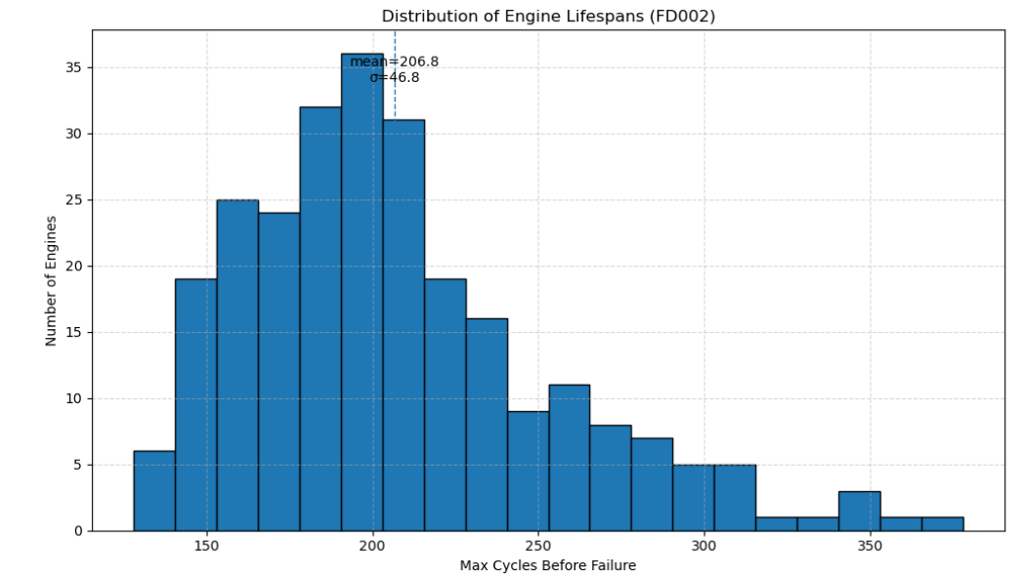

The same capped-then-linear pattern holds (MAX_RUL = 130 then decline). I picked four random engines: they confirm the dataset structure but with more spread across lifetimes (Figure E).

***Figure E.*** Example RUL trajectories showing the 130‑cycle clip then linear decline to failure.

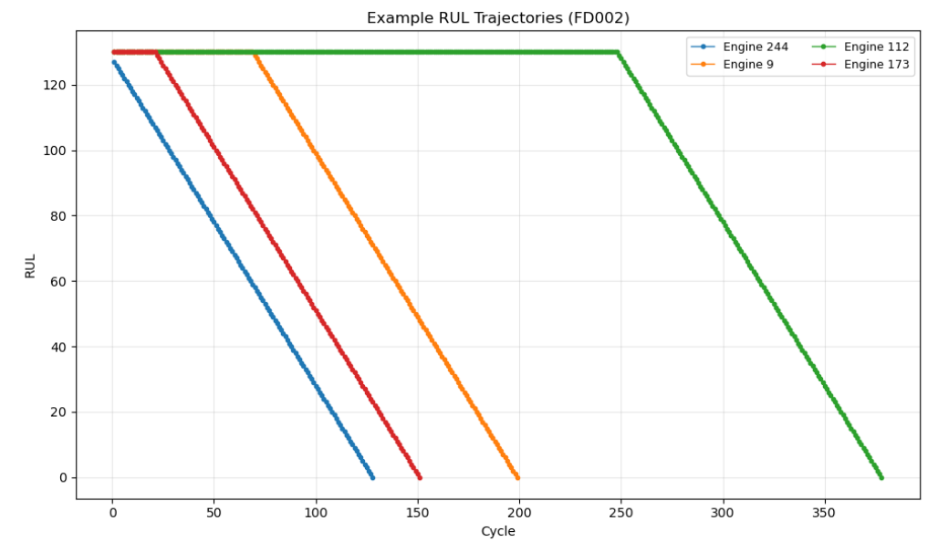

The correlation heatmap (Figure F) shows most sensors are strongly positive with each other, but we also see a few outliers (e.g., sensor 15 shows clear negative behaviour). With multiple operating conditions, we normalised per-condition instead of globally.

***Figure F.*** Sensor correlation heatmap highlighting key clusters.

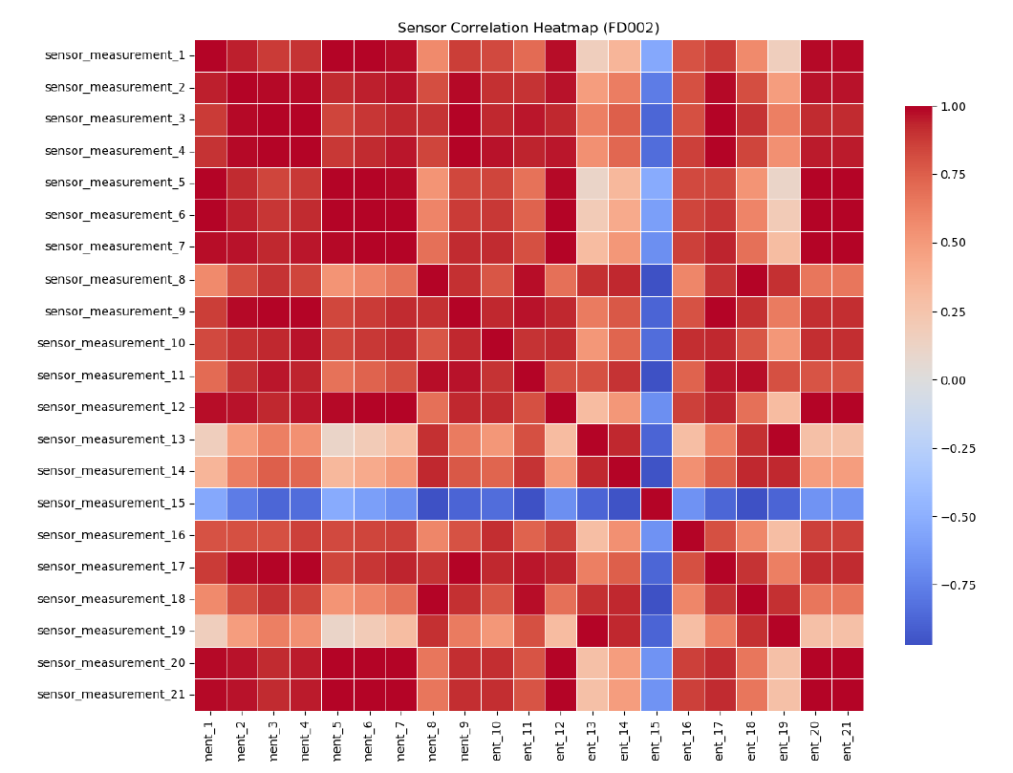

Implications

*FD002 is harder than FD001 because models must cope with condition-driven variation as well as wear. LSTMs are expected to generalise better here, as they can track degradation across regimes, while CNNs may struggle with the shifts.*

Where to look for more details. See **Appendix 2**: base_characteristics FD001 (PDF & notebook) for full statistics, sensor lists and additional plots.

### FD003 - Single Condition/ Dual Faults

#### Context

FD003 introduces dual fault modes while keeping a single operating condition. Compared to FD002, the absence of changing conditions removes regime shifts, but the presence of two simultaneous degradation paths makes the problem more complex.

#### Key characteristics

lifespans spread wider here, ~140–520 cycles (mean ≈247, σ ≈87). Figure G shows the histogram: some engines fail in ~150–200 cycles, while others run well past 400, creating a broader, more variable dataset than FD001/FD002.

***Figure G***. Distribution of engine lifespans

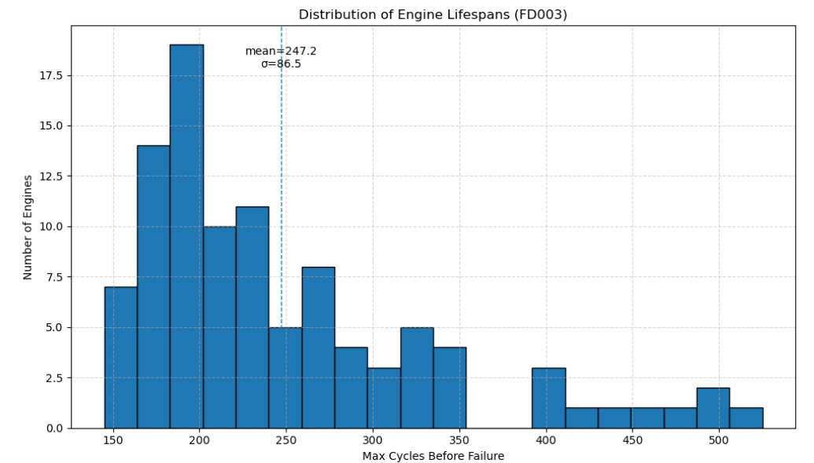

The same capped-then-linear behaviour is present. The four sampled engines (Figure H) illustrate how lifetimes differ widely, yet the drop pattern remains steady once degradation begins.

***Figure H.*** Example RUL trajectories showing the 130‑cycle clip then linear decline to failure.

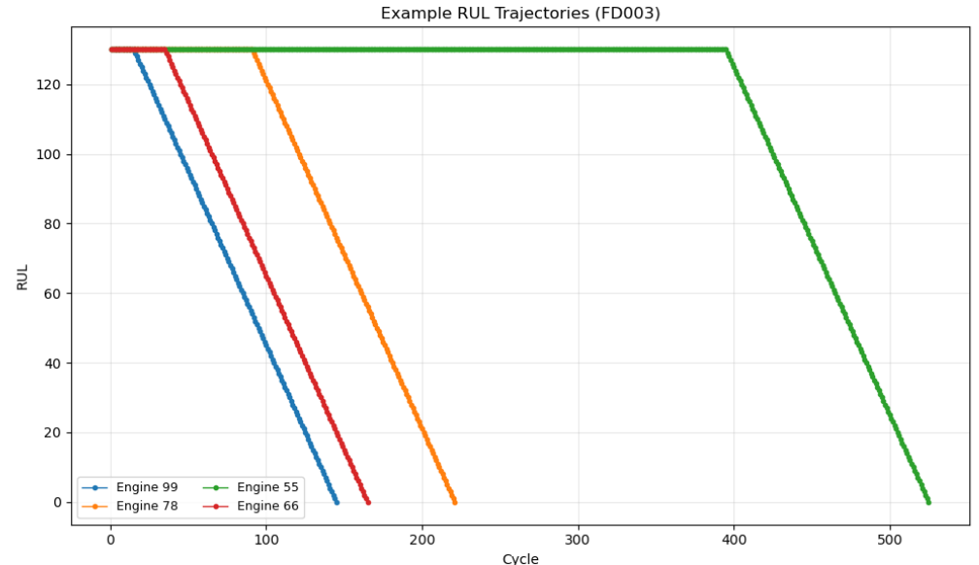

The correlation heatmap (Figure I) reveals clusters of strongly linked sensors but also more negative relationships than in FD001. This reflects the dual-fault nature: some signals move in opposite directions as different subsystems degrade.

***Figure I.*** Sensor correlation heatmap highlighting key clusters.

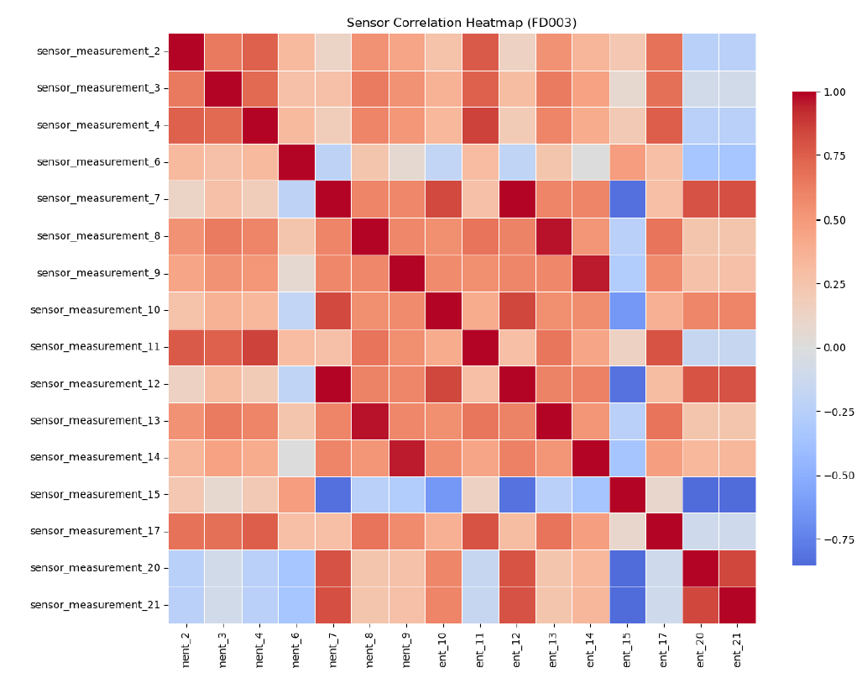

Implications

FD003 is a useful test of whether models can separate overlapping failure signatures. LSTMs are expected to shine by tracking temporal dependencies across both fault types, while simpler models may confuse the signal.

Where to look for more. **Appendix 3**: base_characteristics FD003 (PDF & notebook) contains the full plots and sensor breakdown

### FD004 - Multi-Condition / Dual Faults

#### Context

FD004 is the hardest of the four sets: it combines multiple operating conditions with dual fault modes. This means models must handle both shifting regimes and overlapping degradation signatures.

#### Key characteristics

Lifespans run from ~140 up to ~530 cycles (mean ≈246, σ ≈73). Figure J shows a broad histogram with engines failing anywhere between 150 and 400+, making the distribution much wider than FD001 or FD002.

***Figure J***. Distribution of engine lifespans

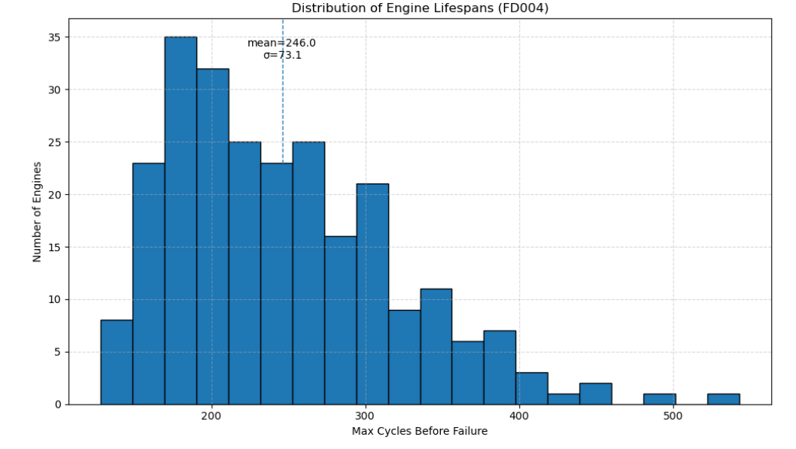

As before, RUL is capped at 130 cycles then falls linearly to zero. The four random engines in Figure K show the same structural pattern but with very different overall lifetimes, from ~130 to beyond 500 cycles.

***Figure K.*** Example RUL trajectories showing the 130‑cycle clip then linear decline to failure.

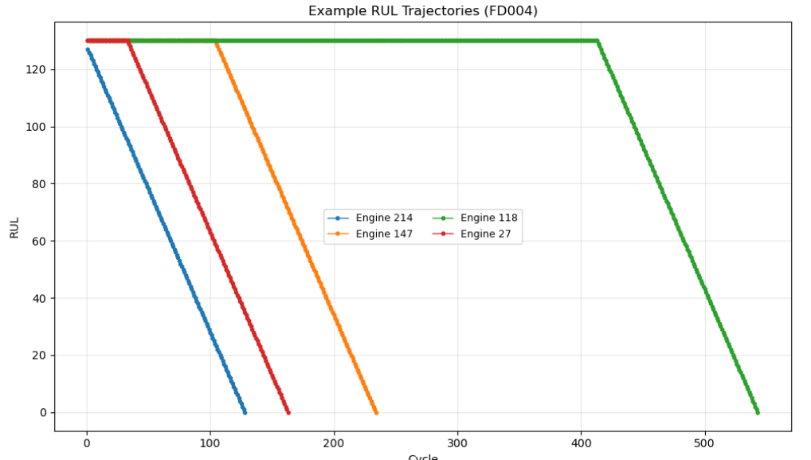

The heatmap (Figure L) shows strong clusters with some negative relationships (e.g., sensor 15).

***Figure L.*** Sensor correlation heatmap highlighting key clusters.



#### Implications

FD004 is the toughest benchmark: models are tested on their ability to generalise across conditions and fault types simultaneously. Performance here gives the clearest signal of robustness.

### Cross Dataset Contrasts

Across the four datasets, FD001 stands as the cleanest baseline: a single operating condition and a single fault type, with lifespans tightly clustered around 200 cycles. FD002 introduces multiple operating conditions, which broaden the lifespan distribution and require models to adjust predictions for regime shifts. FD003 keeps a single condition but adds dual fault modes, widening the spread of engine lives and producing more complex sensor interactions. Finally, FD004 combines both multi-condition and dual fault, yielding the most challenging mix: broad lifespan variability, strong and opposing sensor signals, and the need for models to untangle both operating effects and overlapping degradation patterns.

In practical terms:

* FD001 is expected to produce the lowest errors and serves as a sanity check.
* FD002 stresses robustness across conditions.
* FD003 tests a model’s ability to handle multiple degradation pathways under a stable condition.
* FD004 provides the toughest benchmark, where only the most generalisable models maintain accuracy.

## Pre-processing summary

### FD001 – Pre-processing

The raw data was first loaded and aligned with its RUL labels. Targets were created using the MAX_RUL clipping of 130 cycles to reduce early-life dominance. We split by engine unit before scaling, ensuring no leakage between train/validation/test. Flat sensors (1, 5, 10, 16, 18, 19) were dropped using the training set only, then removed consistently from Val/test. A single Standard Scaler was fitted on the remaining train sensors and applied to all splits (since FD001 has one operating condition). Finally, sequences of length 30 cycles were generated for model input. After preprocessing, we retained 80 engines for training and 20 for validation, with X_train shaped (14241, 30, 15).

### FD00 2 – 4 Pre-processing

The same general pipeline was followed as with FD001, but with one key difference: datasets with multiple operating conditions (FD002 and FD004) required scaling per condition. After calculating RUL with a maximum cap of 130 cycles, we split by engine unit to prevent leakage, dropped flat sensors identified from the training set, and built true RUL values for test units using the provided RUL files. For FD002 and FD004, condition keys were derived from operating settings and separate scalers were fitted per regime. For FD003, which has a single condition, a global scaler was applied as in FD001.

Across all three datasets, once scaling was applied, sliding windows of 30 cycles were generated for model input, creating consistent train, validation, and test arrays. This ensured comparability across datasets while adapting appropriately to regime variability.

Goal: Only the decisions that materially affect interpretation.

* Sliding-window length (seq_len), input features used, target definition.
* MAX_RUL clipping (130) reduces dominance of early life; stabilises learning.
* Per-condition scaling for FD002/FD004; simple global scaling for FD001/FD003.

Pointer to full details in **Methodology/Appendix** 5, 6, 7 & 8.

## Model Build

Following the completion of pre-processing, the datasets were ready for model training. Below is a summary of how each model was constructed, with reference to accompanying diagrams that illustrate their architecture.

### Base model (Linear Regression)

As a benchmark, we used a very simple model: each 30-cycle sequence was flattened into a 2D vector (using the last time step as representative), and a standard linear regression was trained. This gave us a baseline expectation if deep learning models cannot significantly outperform this, their added complexity isn’t justified.

***Figure M:*** *Baseline model (Linear Regression)*.

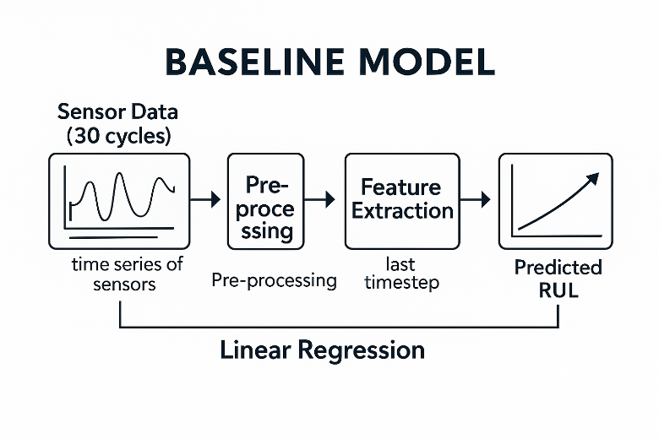

### CNN:

The CNN was designed to pick up local temporal patterns in the sensor data. Using 1D convolutions across the time axis, the network captures short-term dependencies like sudden shifts in sensor readings. It was trained for 30 epochs with batch size 128, and early stopping ensured we did not overfit. The CNN effectively acts as a pattern recogniser, turning each input window into a set of learned feature maps.

**Figure N:** CNN model

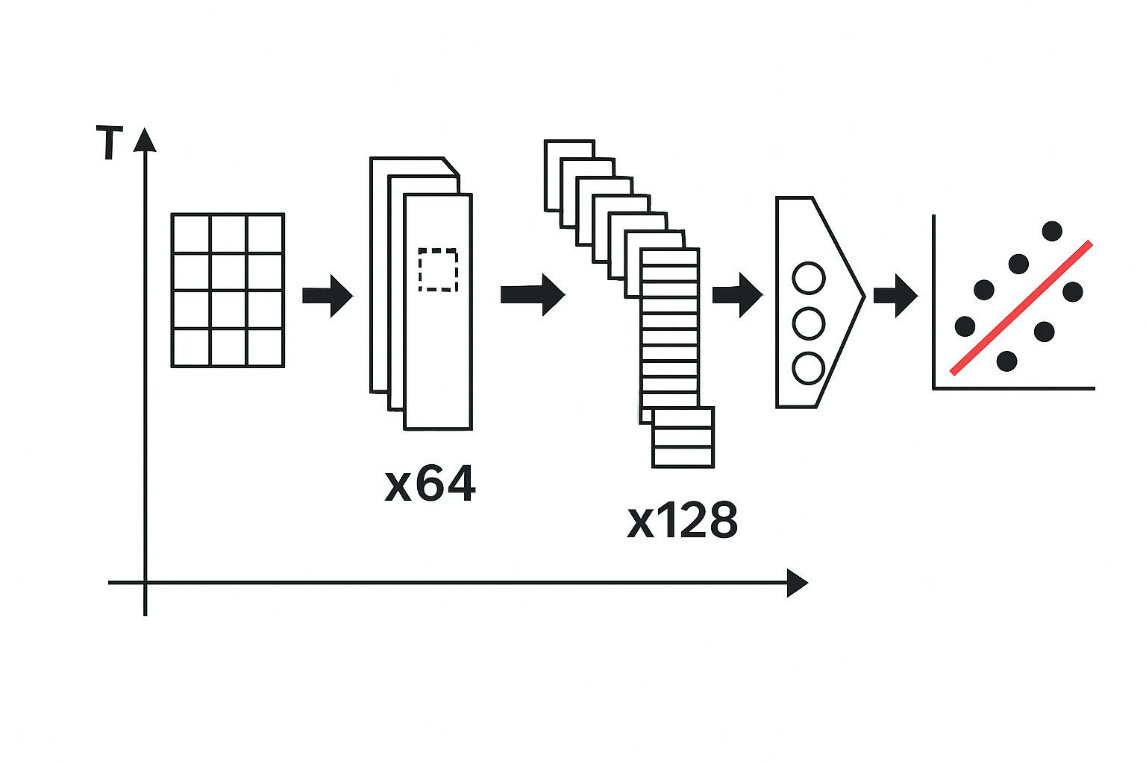

### LSTM:

The LSTM was built to model longer-term dependencies in the degradation process. Unlike the CNN, which looks at short patches, the LSTM can keep track of trends across the entire 30-cycle window, remembering how degradation evolves over time. We trained for 50 epochs (batch size 128), allowing the model to converge steadily. The training logs show a gradual decrease in loss over many epochs, highlighting the LSTM’s strength in learning temporal dynamics.

**Figure O:** LSTM model

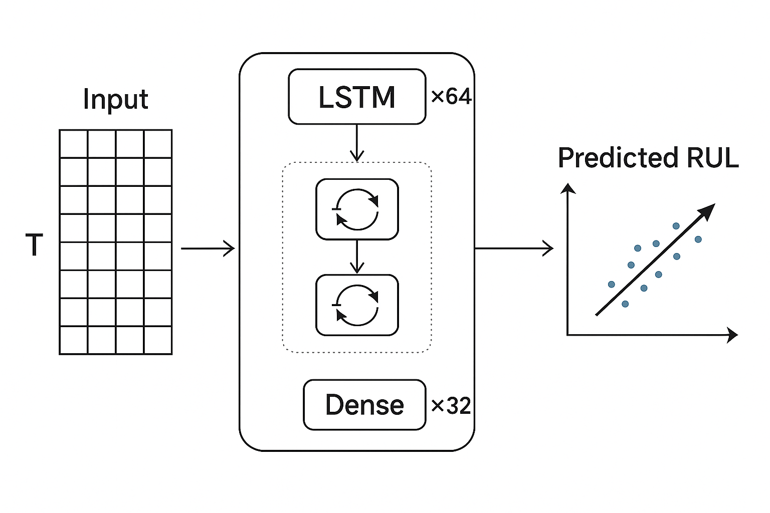

### CNN–LSTM hybrid:

The hybrid combines the strengths of both approaches: CNN layers first extract local temporal features, and the output is then passed into LSTM layers that capture the broader progression. In other words, the CNN acts as a feature extractor and the LSTM as a temporal modeller. This model was also trained for 50 epochs with batch size 128. By design, it should perform well on datasets like FD003/FD004 where both local sensor correlations and long-term temporal signals matter.

**Figure P:** CNN–LSTM hybrid

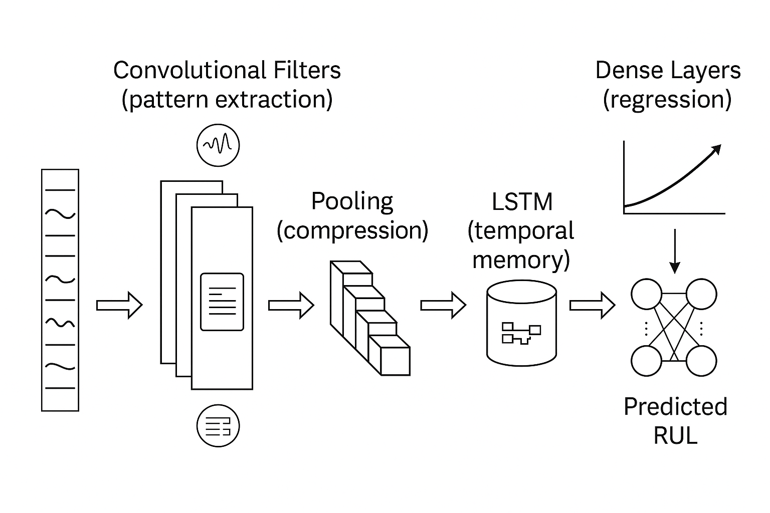

## Model Performance

We now turn to model performance. Based on our preprocessing design choices (e.g., clipping RUL at 130 cycles) and insights from the literature review, we selected a baseline linear regression, a 1D CNN, an LSTM, and a CNN–LSTM hybrid. These models represent industry standards in RUL prediction. The purpose here is not to iteratively optimise or redesign them, but to evaluate their relative strengths. Our aim is to identify which deep learning approach is most effective for this problem, leaving further tuning and extension for future work.

### Summary Plots & Table across FD001–FD004

**Figure Q:** Model ranking across datasets (RMSE and MAE).

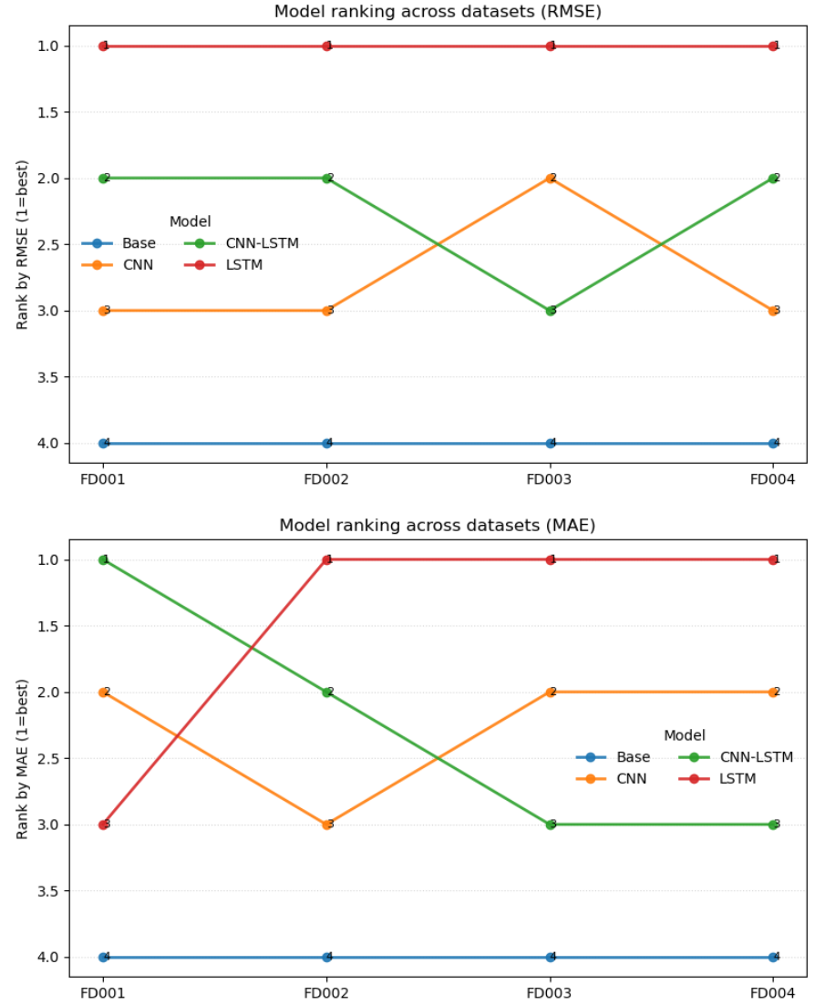

Across all datasets, the LSTM consistently ranked first by RMSE and MAE, showing clear superiority. The CNN and CNN–LSTM alternated between second and third place depending on dataset complexity, while the baseline was always last. This reinforces that temporal models are most robust, but CNNs and hybrids still provide meaningful competition.

**Figure R:** Summary table of RMSE and MAE by dataset and model.

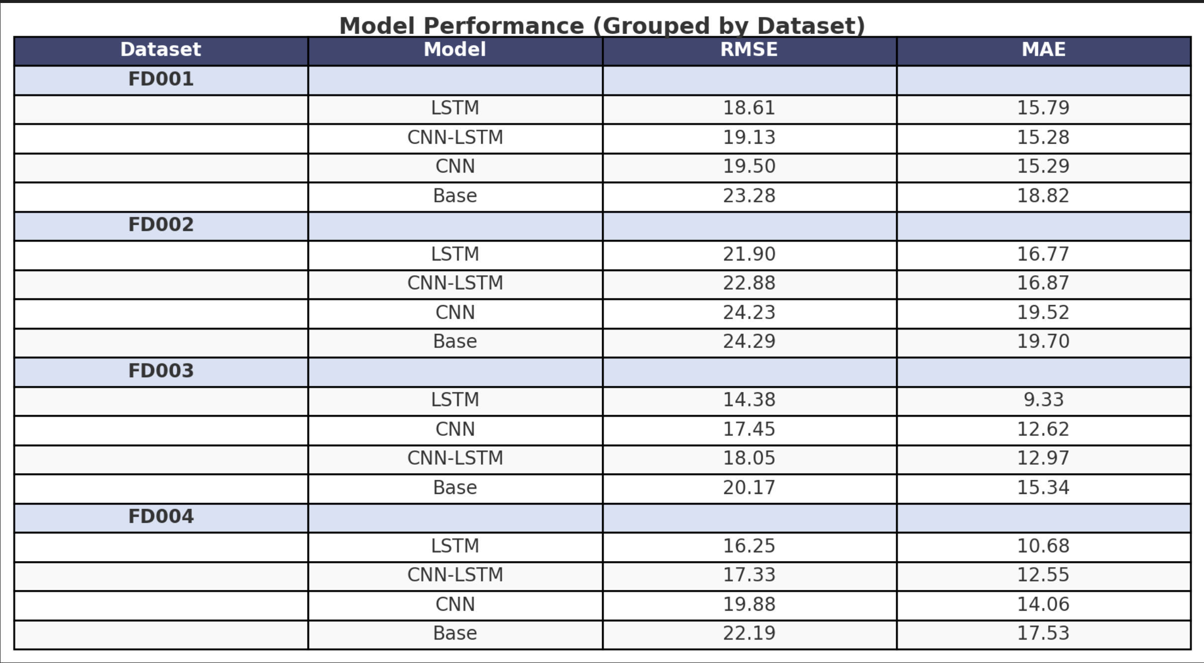

The table confirms that LSTMs achieve the lowest RMSE and MAE on all four datasets, with their advantage most pronounced on FD003 and FD004. CNN–LSTM hybrids performed close to LSTMs but lagged slightly, while CNNs were competitive but more affected by condition shifts (FD002/FD004). The baseline regression showed the highest errors throughout, validating the need for deep learning approaches.

**Figure S:** Heatmaps of RMSE and MAE (lower is better).

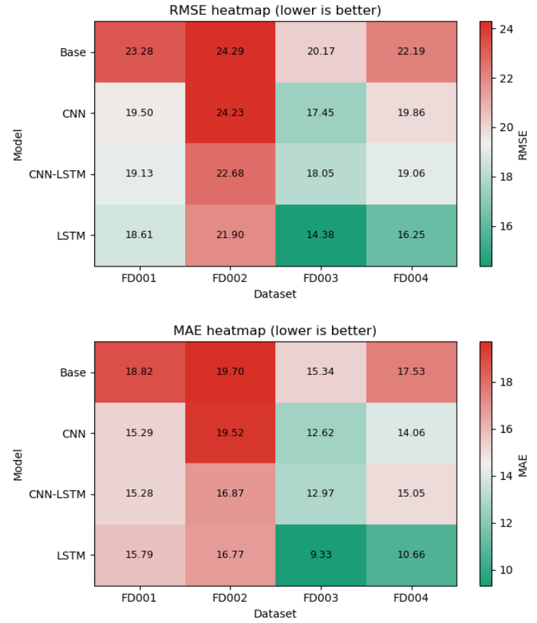

The heatmaps visually highlight the LSTM’s dominance with the darkest green cells across datasets, especially FD003 (RMSE = 14.38, MAE = 9.33). CNN–LSTM appears consistently strong, but slightly weaker than pure LSTM, while CNN performs better on simpler datasets. The red blocks for the baseline emphasise its consistent underperformance relative to all deep models.

### Practical effect

RMSE can be interpreted directly in cycles of RUL. For instance, an RMSE of 18.6 implies the model is typically within ±19 cycles of the true failure point. Assuming an aircraft engine averages ~6 flight cycles per day, this corresponds to roughly three days of scheduling buffer, which is a meaningful planning horizon for inspections and spare-part logistics. For airline planners, such an error margin provides an actionable signal: even if the prediction is not perfect, it prompts human review and inspection of the affected engine. This early warning allows planners to adjust maintenance slots, staffing, and spare allocation in advance, reducing the risk of unplanned groundings. While integrating this process into day-to-day fleet operations can be complex, the predictive buffer is valuable as an indicator to trigger proactive checks and informed planning.

MAE provides an estimate of the typical prediction error in cycles. For example, an MAE of 15 cycles means that most forecasts are within ±15 cycles of the actual RUL, corresponding to about 2–3 days of flight operations. While RMSE highlights the risk of large deviations, MAE gives planners a clearer sense of the day-to-day reliability of the predictions.

## Diagnostic & Error Analysis

Now we need to dive into the models in more depth. The performance summary has already shown which architectures perform best overall, but those numbers only tell part of the story. To avoid unnecessary repetition, we will not re-run the same diagnostic plots for every model on every dataset. Instead, based on the performance patterns observed in Section 4.3, we select one representative model per dataset for closer inspection. This choice lets us explore why the models behave as they do, without overwhelming the reader with redundant material.

By focusing on a single model for each dataset (FD001 baseline, FD002 CNN, FD003 LSTM, FD004 CNN–LSTM), we can highlight both strengths and weaknesses in context: the baseline shows the limits of simple regression, the CNN illustrates sensitivity to operating conditions, the LSTM demonstrates temporal modelling power, and the hybrid faces the toughest dual-fault, multi-condition case. Together, these analyses provide richer insight into model behaviour than raw metrics alone.

### FD001 Baseline Model Analysis

#### Calibration (True vs Pred)

The calibration scatter shows that the baseline linear regression systematically underestimates RUL at high values (flattening out near the 130-cycle cap) and overestimates slightly at very low RUL. The diagonal reference line highlights the gap: predictions fail to track the true decline into failure. This reflects the model’s linear simplification it cannot capture the curved degradation trajectory, only a rough average trend.

**Figure T:** Calibration plot (True vs Pred, baseline FD001)

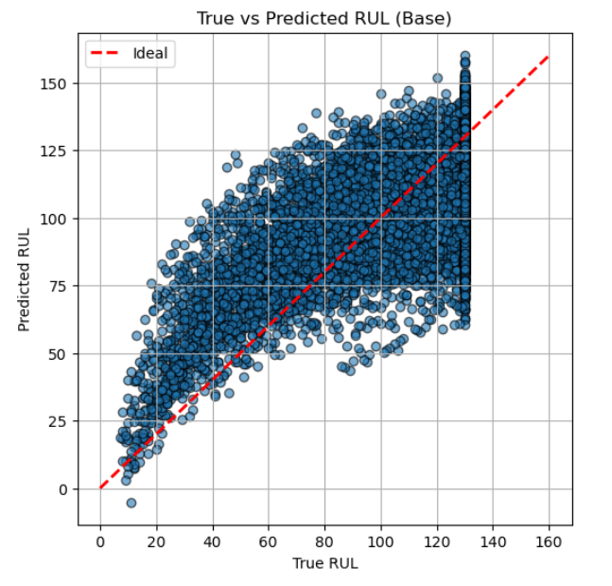

#### Residual distributions & bias

The residual violin plot indicates a wide error spread (≈±60 cycles), with a slight positive skew (predicted > true). This bias confirms what we saw in calibration: the baseline often over-predicts remaining life when failure is near. For maintenance, this is risky because over-estimation leads to late interventions, the costliest error type in PHM.

**Figure U:** Residual error distribution (baseline FD001)

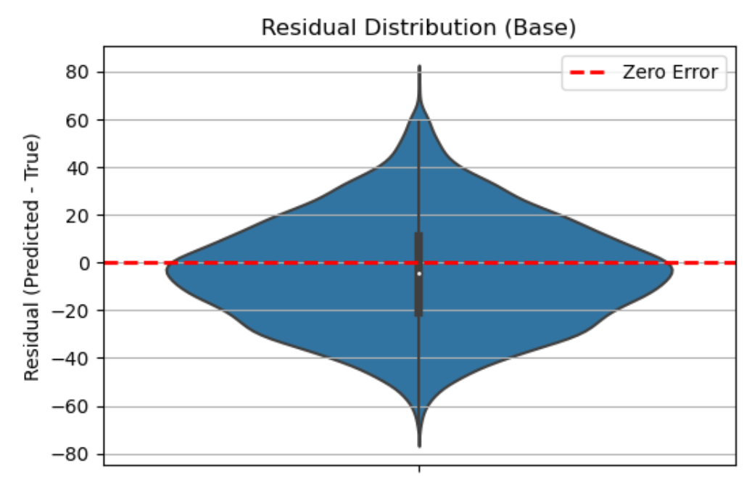

#### Per-engine variability

The per-engine bar chart (Actual vs Predicted RUL for sampled engines) highlights strong engine-to-engine variability. Some engines are predicted reasonably close, while others show 30–50 cycle errors. Because the baseline lacks temporal memory, it treats each engine trajectory, similarly, missing idiosyncratic degradation paths. This makes it unsuitable for fleet-level prediction where variability must be accounted for.

**Figure V:** Per-engine error variability (baseline FD001)

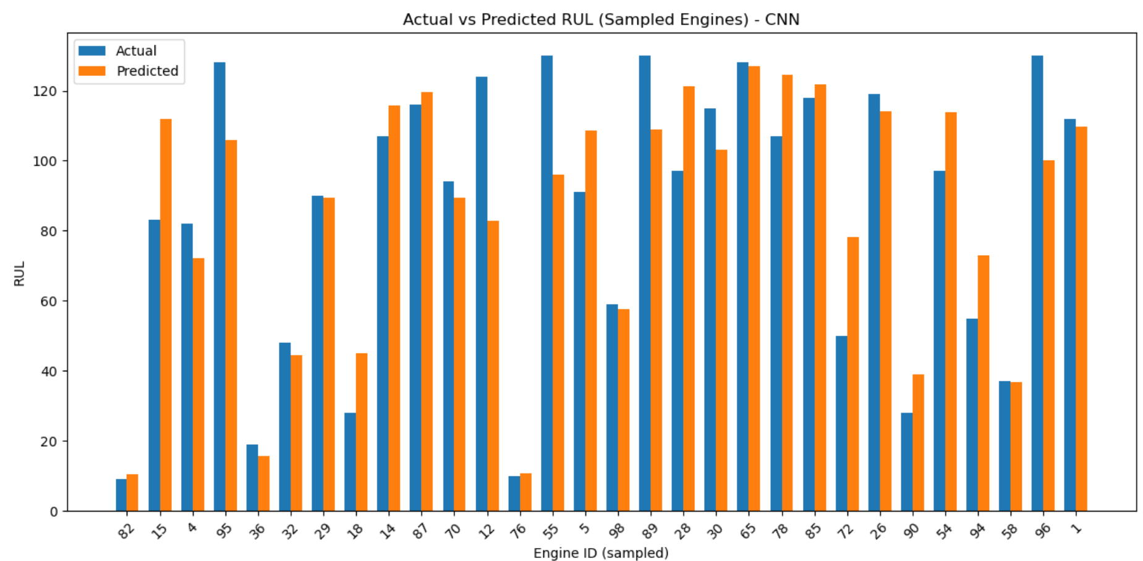

In summary: FD001’s baseline regression demonstrates the limits of a simple model systematic calibration bias, wide residual spread, and high per-engine variability. It serves well as a benchmark, but its shortcomings underline why more advanced temporal models (LSTM/CNN-LSTM) are necessary.

### FD002 CNN Model Analysis

#### Calibration (True vs Pred)

The scatterplot shows that CNN predictions generally align with the true RUL trend, but with greater dispersion compared to FD001. At lower RUL values (<40 cycles), predictions are tight around the ideal line, which is encouraging for short-term maintenance alerts. However, at higher RULs the spread widens, with CNN tending to over-predict engine life. This is consistent with the challenge of disentangling degradation signals from condition-driven variability in FD002.

**Figure W:** Calibration plot (True vs Pred, CNN FD002)

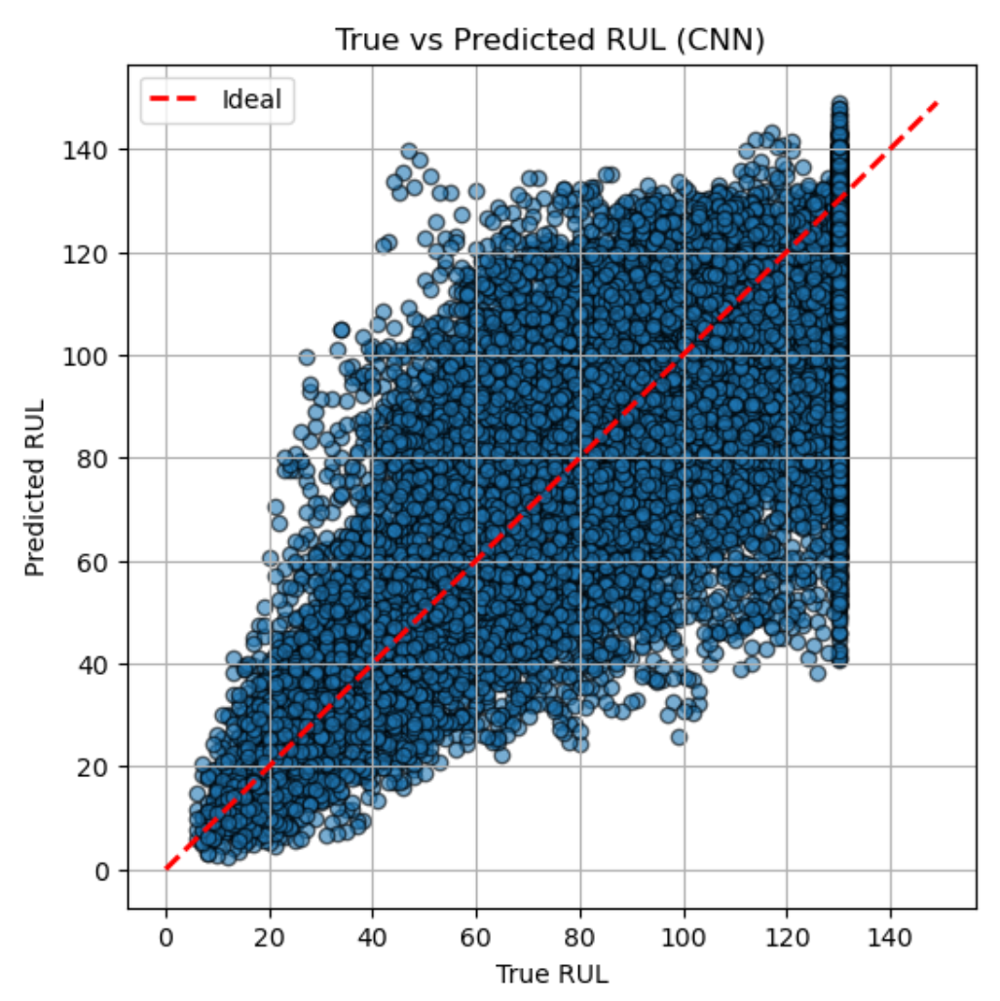

#### Residual distributions & bias

The residual violin plot confirms a systematic negative bias: many points lie below zero, meaning the CNN underestimates RUL (predicting failures earlier than reality). This conservatism is not necessarily problematic in aviation – it errs on the side of caution – but it does increase the risk of premature interventions. The long tails show occasional overestimates, indicating some engines are predicted to last far longer than they do.

**Figure X:** Residual error distribution (CNN FD002)

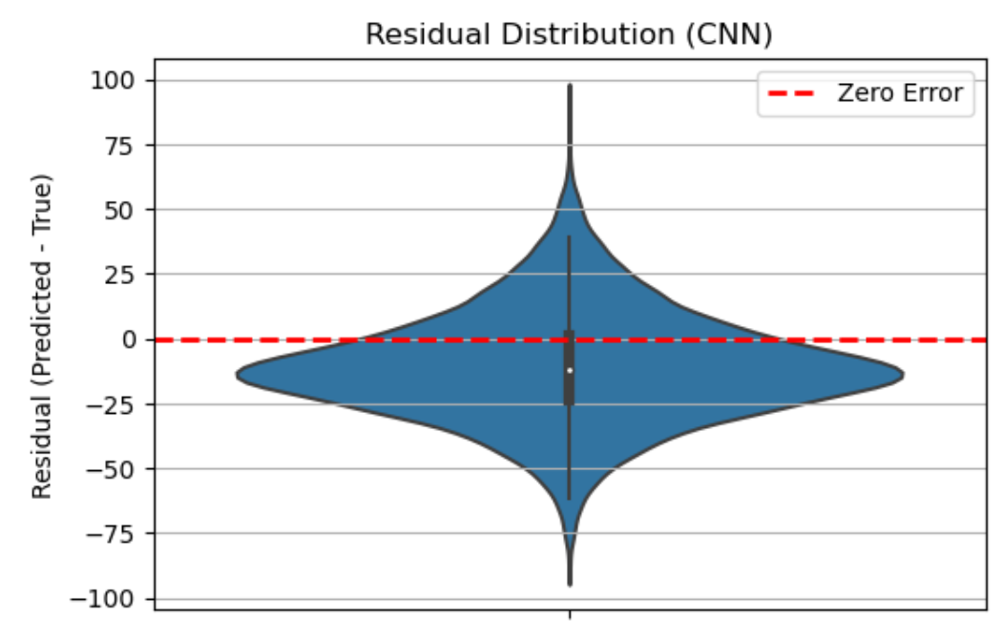

#### Per-engine variability

The bar plot of sampled engines highlights substantial variability across units. For some engines, CNN tracks the true RUL closely, while for other predictions diverge sharply, particularly in mid-life cycles. This engine-to-engine inconsistency illustrates the difficulty CNNs face in handling regime shifts. The model captures local sensor patterns well but struggles to generalise degradation trends across different operating conditions.

**Figure Y:** Per-engine error variability (CNN FD002)

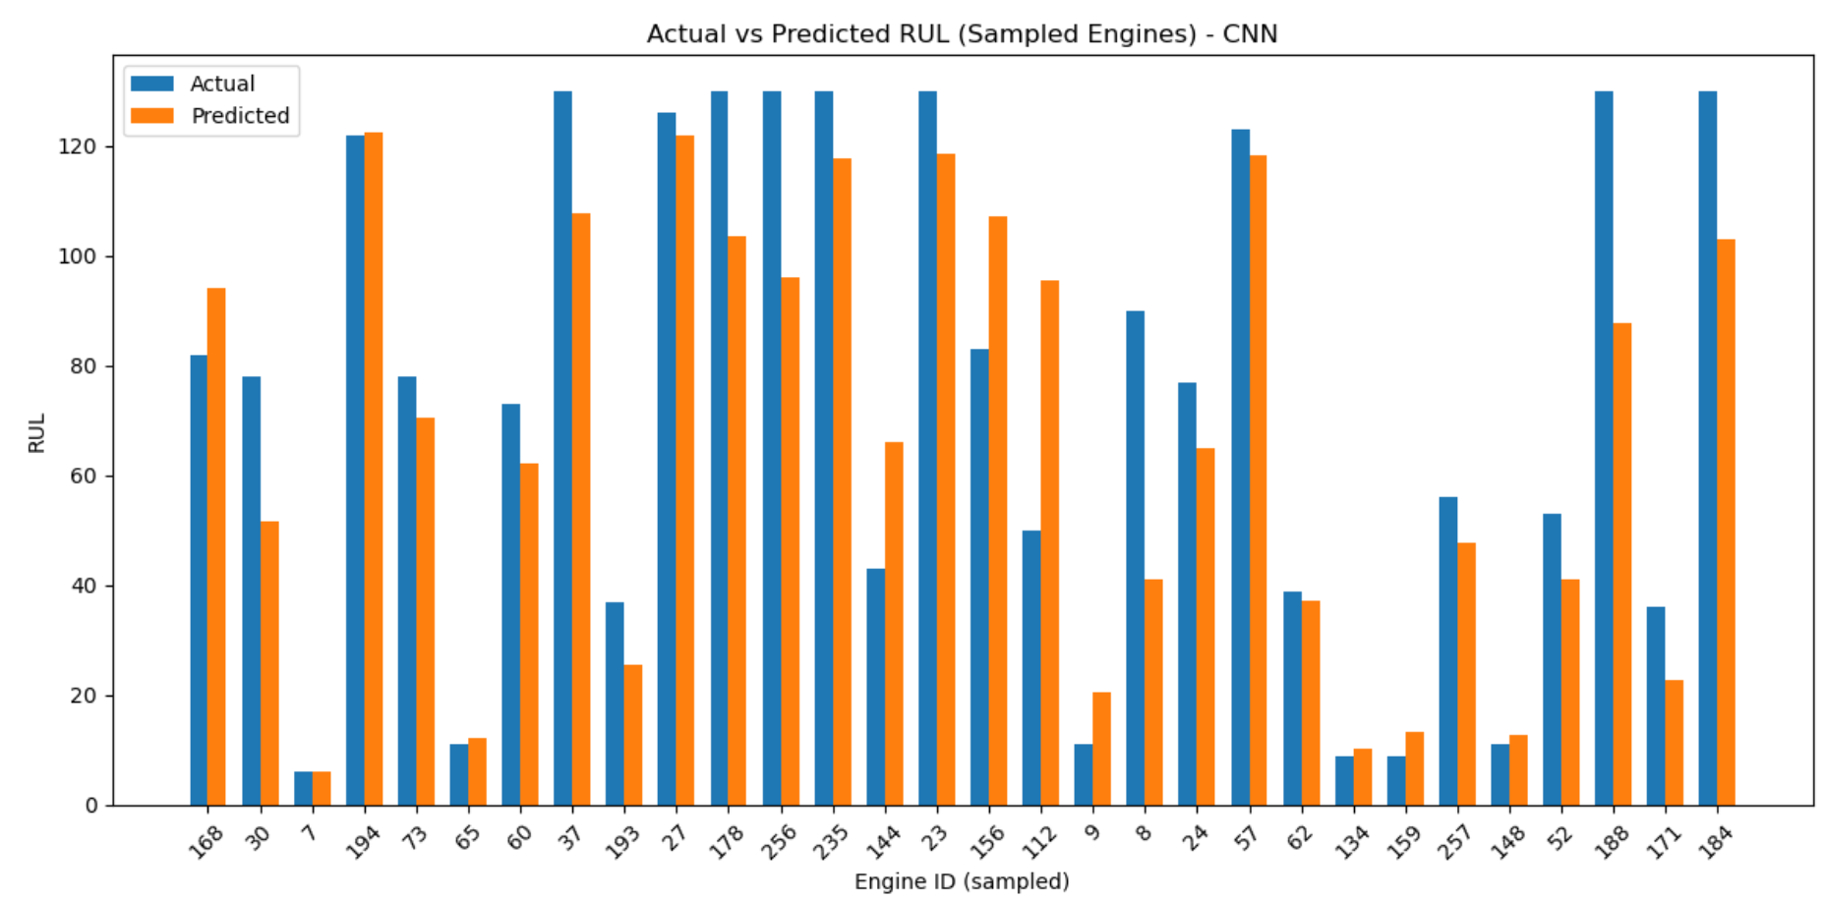

On FD002, the CNN shows solid short-term calibration but weaker performance at longer horizons, with a general tendency to underestimate RUL. While this cautious bias may be acceptable in safety-critical contexts, the engine-level variability reduces reliability for fleet-wide planning. This aligns with our earlier conclusion that LSTM-type models are better suited for multi-condition datasets, as they can model temporal dependencies more effectively than CNNs alone.

### FD003 LSTM Model Analysis

#### Calibration (True vs Pred)

The calibration scatter shows that the LSTM tracks the ideal 45° line very closely across the entire range of RUL values. At low RUL (<30 cycles), predictions are particularly accurate, which is critical since maintenance decisions are most sensitive here. In the mid-range (30–90 cycles), the model maintains tight clustering, although some spread begins to emerge as engines diverge in their dual-fault degradation patterns. At the upper end near the capped 130 cycles, predictions begin to saturate, reflecting both the dataset’s artificial cap and the model’s conservative bias not to over-predict excessively. Compared to FD001 and FD002, this calibration demonstrates clear improvement, highlighting the LSTM’s ability to capture long-term temporal dependencies under dual-fault stress.

**Figure Z:** Calibration plot (True vs Pred, LSTM FD003)

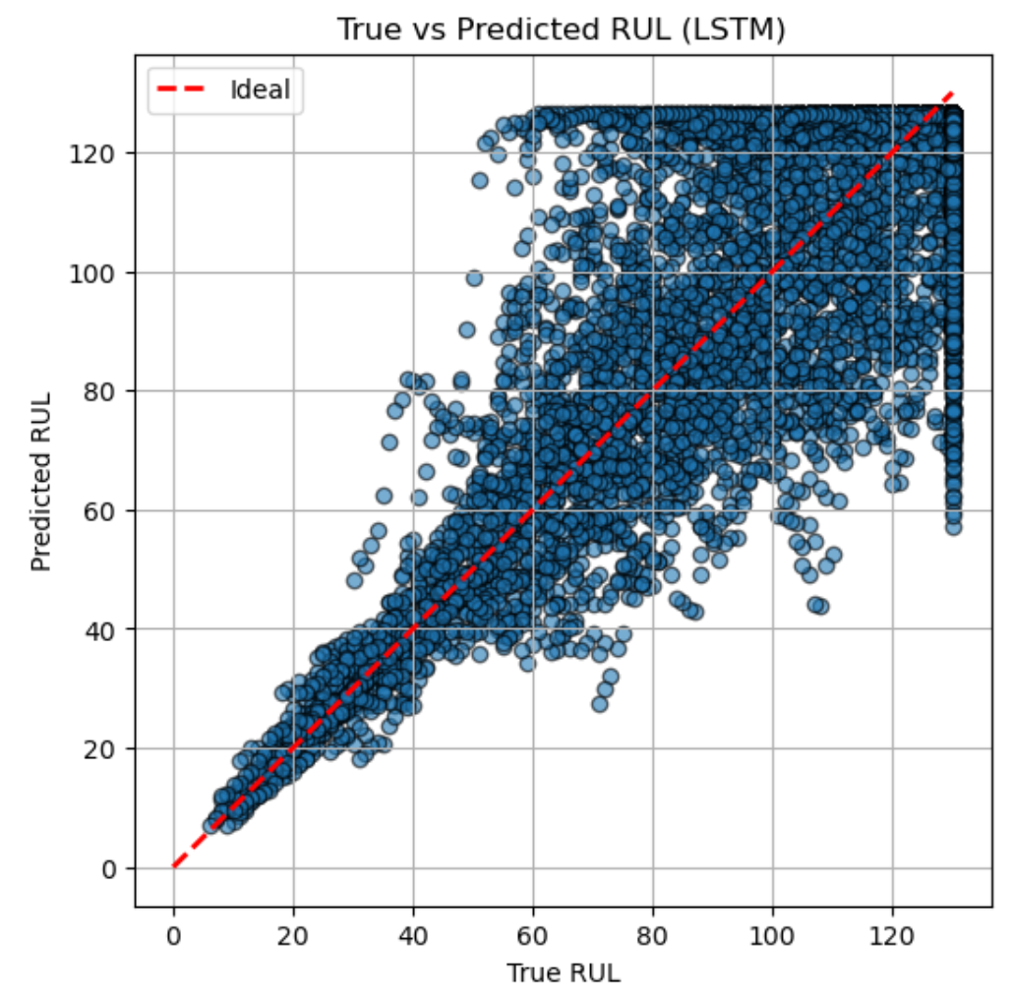

#### Residual distributions & bias

The violin plot shows a compact distribution centred around zero, confirming that the LSTM is largely unbiased. Unlike the CNN on FD002, which skewed toward underestimation, the LSTM balances over- and under-predictions. Most residuals fall within ±20 cycles, a tighter spread than in earlier datasets. Occasional outliers reach ±60 cycles, but these are rare and likely linked to atypical sensor behaviour in engines with unusually long lifespans. The narrow waist of the violin indicates that for most cases, the LSTM provides predictions very close to the true values.

**Figure AA:** Residual error distribution (LSTM FD003)

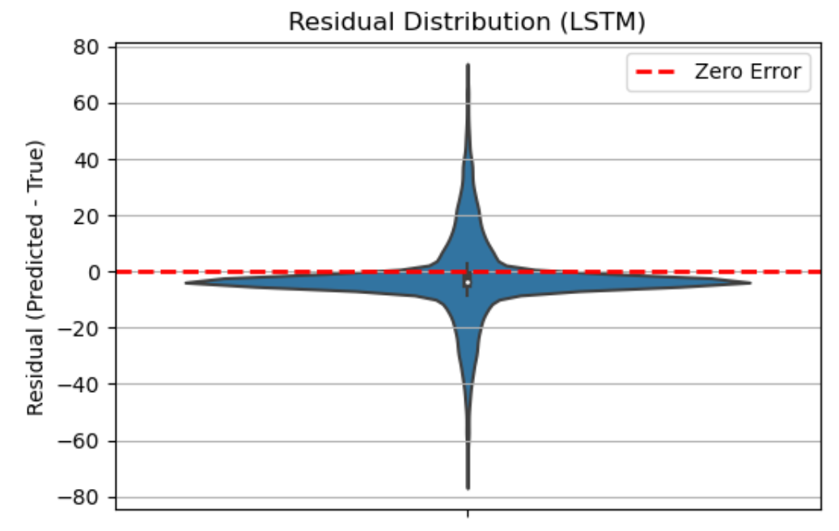

#### Per-engine variability

The bar chart of sampled engines demonstrates consistency: the orange (predicted) bars generally track very close to the blue (actual) bars, regardless of whether the engine failed early or ran beyond 300 cycles. This stability across different degradation pathways is particularly important in FD003, where the dual-fault setup could easily confuse weaker models. The LSTM’s temporal memory enables it to follow engine-specific progression without collapsing predictions to a generic mean trend.

**Figure AB:** Per-engine error variability (LSTM FD003)

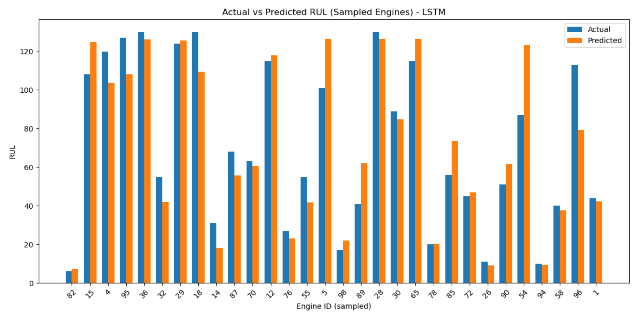

On FD003, the LSTM shows its strongest performance so far. Calibration is tight across short, medium, and long horizons; residuals are centred and narrow; and engine-to-engine variability is well captured. This confirms that LSTM is the most suitable model for dual-fault, single-condition datasets: it can disentangle overlapping degradation signals while preserving accuracy across a broad range of lifespans. In practical PHM terms, the model delivers reliable early warnings with limited false alarms, providing planners confidence to schedule interventions without over-maintaining engines.

### FD004 hybrid Model Analysis

#### Calibration (True vs Pred)

The calibration scatter shows the CNN–LSTM following the ideal 45° line reasonably well, though with more spread compared to the LSTM on FD003. Predictions at low RUL values (below ~30 cycles) are fairly accurate, but at mid to high RUL, a wider dispersion is visible. Some points cluster around the 130-cycle cap, a sign that the model occasionally overestimates remaining life under complex dual-fault, multi-condition settings. Still, the CNN–LSTM tracks the general trend, suggesting it can learn both local and long-term degradation patterns but struggles with extreme variability.

**Figure AC:** Calibration plot (True vs Pred, Hybrid FD004)

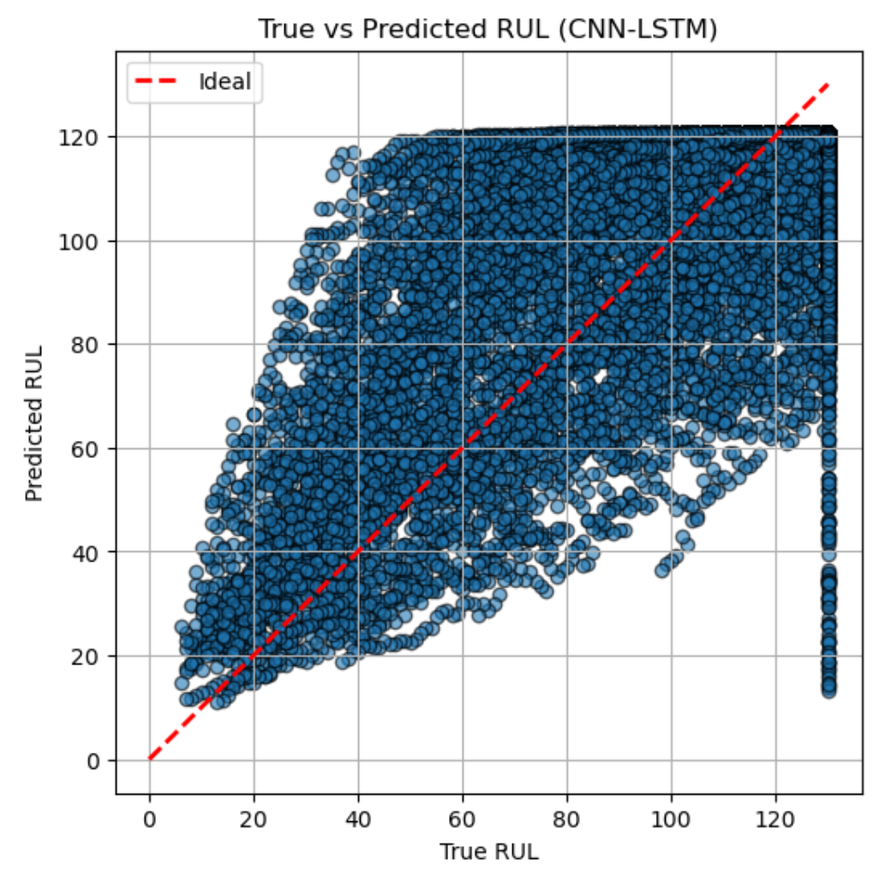

#### Residual distributions & bias

The residual plot shows a narrow concentration of predictions around zero, but with heavier tails than in FD003. This indicates occasional large errors both under- and over-predictions reflecting the difficulty of FD004. The bulk of residuals lie within ±20 cycles, which is operationally acceptable, but the presence of outliers reaching ±100 cycles is a weakness in reliability. Interestingly, the distribution’s centre sits slightly below zero, showing a small under-prediction bias (forecasting failures earlier than they occur). While conservative, this bias is not necessarily harmful in aviation, where early warnings are safer than late surprises.

**Figure AD:** Residual error distribution (Hybrid FD004)

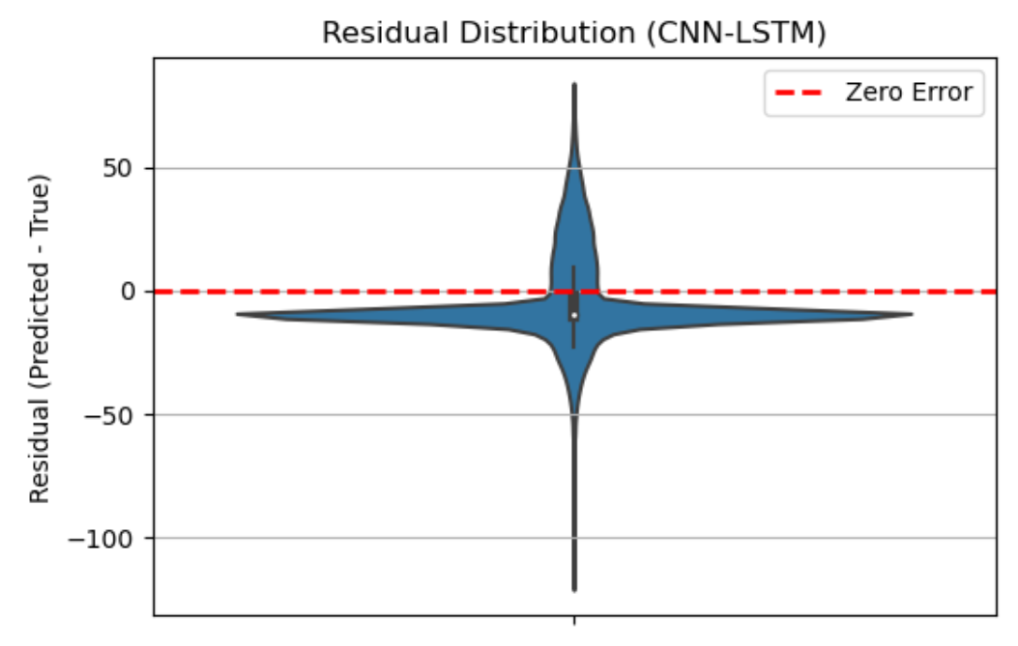

#### Per-engine variability

The sampled engine bar chart reveals mixed performance. For most engines, predicted RULs track the actual values closely, but in several cases, the model under-predicts heavily (e.g., engines with long lifespans are cut short in prediction). This reflects the challenge of FD004: engines degrade under both multiple conditions and dual failure modes, requiring the model to disentangle complex patterns. The hybrid’s CNN layers help capture local anomalies, while the LSTM handles temporal dependencies, but the interaction is not perfect leading to uneven accuracy across engines.

**Figure AE:** Per-engine error variability (Hybrid FD004

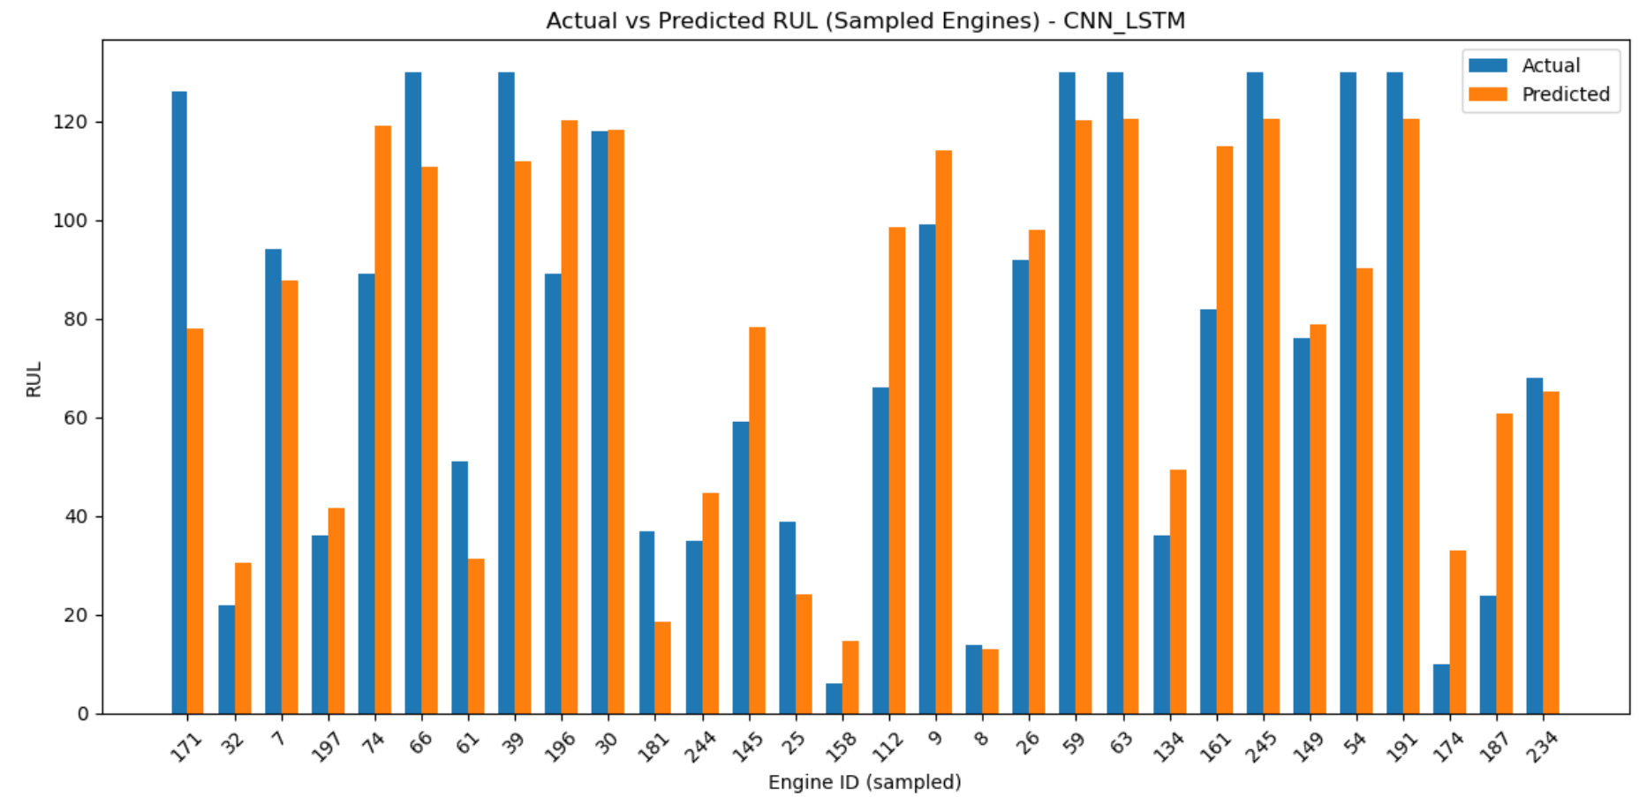

On FD004, the CNN–LSTM delivers competent but less consistent results compared to the LSTM on FD003. Calibration is broadly aligned but more scattered, residuals are centred but fat-tailed, and per-engine performance is uneven with occasional sharp under-predictions. This highlights the difficulty of FD004 as the most complex dataset. Still, the hybrid demonstrates value: it remains competitive across both short- and long-term horizons, balancing CNN’s local pattern detection with LSTM’s temporal modelling. From a PHM perspective, its conservative under-prediction bias means planners receive early alerts, which, while imperfect, provide actionable buffers for maintenance scheduling in a high-stakes aviation setting.

Taken together, the diagnostics highlight a clear progression: the FD001 baseline exposes the limits of simple linear models, FD002 shows how CNNs struggle with condition variability, FD003 demonstrates the LSTM’s strength in capturing dual-fault temporal dynamics, and FD004 confirms both the promise and the fragility of hybrids in the most complex setting. Across all four datasets, the analyses reinforce why temporal deep learning remains the most reliable foundation for PHM.

Pointer to full details in on analysis of each model on each dataset see **Appendix** 5, 6, 7 & 8.

## Threats to Validity / Limitation

### Data-related threats

The C-MAPSS dataset, while widely used, is a synthetic simulator rather than real-world engine data. This limits how representative the results are of actual fleet behaviour, where noise, maintenance history, and operating environments are more complex. Furthermore, the dataset only covers specific fault types and operating regimes, which narrows the scope of conclusions. Dropping flat sensors during preprocessing also carries risk: weak but potentially informative signals may have been discarded, reducing the models’ ability to capture subtle degradation indicators.

### Methodological threats

The preprocessing and modelling pipeline involved fixed design choices, such as a 30-cycle sequence length, that may bias results toward certain temporal structures. Hyperparameters (epochs, batch size, learning rate) were tuned only lightly due to time constraints, meaning stronger architectures may not have been fully explored. Training relied on a single train/validation split, rather than repeated runs or cross-validation, which increases sensitivity to how the data happened to be partitioned. Early stopping was used to reduce overfitting but may also have limited model convergence.

### Model-related threats

The models chosen baseline regression, CNN, LSTM, and CNN–LSTM reflect industry standards, but their specific implementations introduce limitations. The baseline regression is extremely simple, which may exaggerate the performance gap to deep learning models. The CNN–LSTM hybrid is highly sensitive to architectural design and may underperform if configured sub-optimally; other variants could achieve better results. Similarly, the choice of two-layer LSTM reflects a balance between complexity and training stability, but deeper or attention-based models might capture dependencies more effectively.

### Evaluation threats

The study primarily used RMSE and MAE as evaluation metrics, which are standard but limited. Both treat early and late prediction errors equally, even though in PHM contexts late predictions are costlier than early ones. Outliers also play a large role in RMSE, so a small number of extreme errors may distort results. In addition, results were reported mainly as averages, which mask per-engine variability that is critical in fleet management. Including the PHM asymmetric scoring metric or reliability-based metrics would provide a more complete picture.

### Generalisability

The findings provide insight into relative model behaviour on C-MAPSS but generalising them to operational aviation requires caution. Real fleets involve messy sensor data, maintenance interventions, and irregular operating cycles that the simulator does not capture. While the LSTM proved most reliable here, deploying it in industry would require retraining with real fleet data, validation under varied conditions, and integration with existing maintenance decision processes. The results therefore should be interpreted as evidence of comparative performance under controlled conditions, not as guarantees of field performance.

## Practical Implications

### Operational translation.

The prediction errors in this study can be directly interpreted in cycles of remaining life. For example, an RMSE of 18–20 cycles equate to roughly three days of flight operations for a short-haul engine completing ~6 cycles per day. This buffer is operationally meaningful: it gives planners time to schedule inspections, order parts, and allocate maintenance slots in advance. Even though perfect accuracy is impossible, consistent early warning by even a few days can reduce costly unplanned groundings and improve overall fleet availability.

### Cost asymmetry in aviation.

In aviation maintenance, the cost of error is not symmetric. An early prediction (replacing a part sooner than strictly necessary) carries some cost in labour and lost component life, but a late prediction (missing an impending failure) risks far greater costs flight disruption, safety concerns, and emergency replacements. The diagnostic analysis showed that models such as CNN and CNN–LSTM tend toward conservative under-prediction, which in practice provides a safer margin. While not optimal for maximising component usage, this bias is valuable in a safety-critical environment.

### Planner’s perspective.

From a supply chain and planning standpoint, these models directly support forecasting demand for spares and scheduling workforce capacity. As someone already working in aviation planning, I see clear parallels: an error margin of ±15 cycles (≈2–3 days) is enough to adjust procurement timelines for critical spares, align with maintenance slots, and communicate with suppliers. While the C-MAPSS dataset is simulated, the principle is transferable predictive models can provide an evidence-based signal to planners, who can then layer human judgment and operational context on top. This strengthens proactive maintenance and reduces the reliance on reactive firefighting in the supply chain.

## Summary of Key Findings

* LSTM was the strongest performer across all four datasets, delivering the lowest RMSE/MAE, particularly on FD003 (dual faults) and FD004 (multi-condition + dual faults).
* CNN struggled with regime shifts in FD002/FD004, confirming that convolution alone cannot fully capture operating-condition variability.
* The hybrid CNN–LSTM was competitive on FD004, but showed less consistency than pure LSTM, underlining the sensitivity of hybrid designs.
* Baseline regression consistently underperformed, highlighting the value of deep learning in modelling temporal degradation.
* Diagnostics revealed systematic biases: CNNs tended to under-predict (safer but premature interventions), while the LSTM remained well-calibrated with narrow residuals and low engine-to-engine variability.
* Practical implications: RMSE/MAE translate into 2–3 days of operational buffer, enough to inform inspections, spares procurement, and proactive scheduling.
* Limitations acknowledged: synthetic data, fixed design choices, and limited hyperparameter tuning. Still, the comparative results provide robust evidence of relative model behaviour.

# Conclusion:

This project set out with a clear aim: to investigate and evaluate the effectiveness of deep learning models, specifically Convolutional Neural Networks (CNNs) and Long Short-Term Memory networks (LSTMs), in predicting the Remaining Useful Life (RUL) of turbofan engines using the NASA C-MAPSS dataset. At its core, the work sought not only to determine which architecture achieved stronger predictive performance but also to understand how such models could be embedded into digital twin frameworks that support predictive maintenance in aviation. From the outset, I approached this challenge with a professional curiosity shaped by my own background in aerospace supply chains, where forecasting parts and anticipating failures is not an abstract academic question but a daily operational necessity.

The findings of this study highlight the strengths and weaknesses of different modelling approaches. The CNN, designed to detect localised degradation patterns, proved effective in extracting spatial correlations across sensor channels. The LSTM, by contrast, demonstrated its value in capturing long-term temporal dependencies, modelling gradual degradation across the 30-cycle windows. The hybrid CNN-LSTM model attempted to bring these strengths together, and while it showed potential, training complexities and resource constraints limited its full optimisation. Across the four datasets (FD001–FD004), results confirmed that no single model is universally superior. Instead, the value lies in recognising how each architecture responds to data complexity: CNNs excelled where fault signatures were pronounced, while LSTMs performed more robustly in scenarios demanding memory of long degradation sequences. Together, these insights provide a nuanced picture rather than a simple winner–loser comparison.

Beyond metrics such as RMSE and MAE, the real contribution of this project is in bridging the gap between theory and practice. A simple baseline linear regression model was deliberately included to ground the deep learning results. This allowed the work to demonstrate how and why advanced architectures outperform traditional methods while acknowledging the trade-offs in computational demand and interpretability. As someone working in aviation planning, I am acutely aware that algorithms do not operate in a vacuum: a model must be transparent enough for engineers to trust its predictions and lightweight enough to run under operational constraints. While deep learning offers clear advantages in predictive accuracy, this project also revealed the importance of explainability and integration a reminder that research does not end with a high score on a benchmark dataset but must translate into tools that industry can adopt with confidence.

Like many technical journeys, this project also carried its share of limitations. Hardware constraints necessitated capping the maximum RUL at 130 cycles and forced compromises on training depth, particularly for the hybrid CNN-LSTM model. The dataset itself, though widely adopted in academic literature, remains a simulation; real-world sensor data would inevitably bring further noise, irregularities, and regulatory considerations that a laboratory pipeline cannot fully capture. These limitations, however, are instructive rather than discouraging. They point directly to areas where future research should focus developing lightweight yet accurate models capable of real-time analysis, integrating explainable AI techniques into prognostics, and testing pipelines on streaming sensor data in live operational contexts.

Ultimately, this dissertation is not only a technical evaluation but also a personal milestone. From the history of railway inspections in the 19th century to NASA’s simulation of turbofan degradation, predictive maintenance has always evolved through cycles of theory, experimentation, and application. In contributing a modular, reproducible pipeline that systematically compares CNN and LSTM approaches across the C-MAPSS datasets, I have added a small but meaningful link in that chain. For me, this project has been more than an academic requirement: it has been a chance to test ideas born in the classroom against challenges I recognise from industry, and to reflect on how digital twins might reshape the future of aviation maintenance. My hope is that this work not only demonstrates academic rigour but also lays the groundwork for practical tools that can save costs, reduce disruptions, and enhance safety in one of the world’s most demanding industries.

# Reference:

* Airbus (2023) A320 Family Aircraft Characteristics. Toulouse : Airbus S.A.S.
* Airbus (2024) Global Market Forecast 2024–2043. Toulouse: Airbus S.A.S.
* ICAO (2022) Annual Safety Report. International Civil Aviation Organization.
* IATA (2025) Economic Performance of the Airline Industry: Mid-Year Report 2025. International Air Transport Association.
* Saxena, A., Goebel, K., Simon, D. and Eklund, N. (2008) ‘Damage Propagation Modelling for Aircraft Engine Run-to-Failure Simulation’, Proceedings of the 1st International Conference on Prognostics and Health Management (PHM08), Denver, CO, October 2008.
* Saxena, A., Celaya, J., Balaban, E., Goebel, K., Saha, B., Saha, S. and Schwabacher, M. (2008a) ‘Metrics for Evaluating Performance of Prognostics Techniques’, Proceedings of the International Conference on Prognostics and Health Management (PHM08), Denver, CO, October 2008.
* Aldrich, M. (2010). Safety First: Technology, Labor, and Business in the Building of American Work Safety, 1870–1939. Johns Hopkins University Press.
* Hochreiter, S. & Schmidhuber, J. (1997). Long Short-Term Memory. Neural Computation, 9(8), 1735–1780. https://doi.org/10.1162/neco.1997.9.8.1735
* IATA (2020). The Cost of Airline Disruptions. International Air Transport Association. Available at: https://www.iata.org/
* Kakoullis, T. & Brady, M. (2018). Digital Twins: The Key to the Future of Maintenance. Journal of Asset Management, 19(5), 321–333. https://doi.org/10.1057/s41260-018-0071-5
* LeCun, Y., Bottou, L., Bengio, Y., & Haffner, P. (1998). Gradient-based learning applied to document recognition. Proceedings of the IEEE, 86(11), 2278–2324. https://doi.org/10.1109/5.726791
* Lee, J., Bagheri, B., & Kao, H.A. (2014). A Cyber-Physical Systems architecture for Industry 4.0-based manufacturing systems. Manufacturing Letters, 3, 18–23. https://doi.org/10.1016/j.mfglet.2014.12.001
* Rolls-Royce (2017). Power by the Hour: A History of Engine Leasing. Rolls-Royce Holdings plc. Available at: https://www.rolls-royce.com/
* Saxena, A., Goebel, K., Simon, D., & Eklund, N. (2008). Damage Propagation Modeling for Aircraft Engine Run-to-Failure Simulation. Proceedings of the 1st International Conference on Prognostics and Health Management (PHM08). Denver, CO. Available at: <https://ti.arc.nasa.gov/tech/dash/groups/pcoe/prognostic-data-repository/>
* W3Schools. (2025). *Python Machine Learning - Data Scaling*. Available at: [https://www.w3schools.com/python/python_ml_scale.asp](https://www.w3schools.com/python/python_ml_scale.asp?utm_source=chatgpt.com) (Accessed: 31 August 2025).
* Brownlee, J. (2024). A Gentle Introduction to Scikit-Learn: A Python Machine Learning Library. Machine Learning Mastery. Available at: https://machinelearningmastery.com/a-gentle-introduction-to-scikit-learn-a-python-machine-learning-library/
* (Accessed: 31 August 2025).
* Abd Wahab, N.H., Hasikin, K., Lai, K.W., Xia, K., Bei, L. & Wu, X. (2024) ‘Predictive maintenance and digital twin technologies: a systematic review of challenges, opportunities, and best practices’, PeerJ Computer Science, 10, e1943. doi: 10.7717/peerj-cs.1943. Available at: https://doi.org/10.7717/peerj-cs.1943
* AIAA & AIA (2021) Digital Twin: Definition & Value – An AIAA and AIA Position Paper. American Institute of Aeronautics and Astronautics; Aerospace Industries Association, 9 February. Available at: https://www.aia-aerospace.org/publications/digital-twin-definition-value-an-aiaa-and-aia-position-paper/.
* Burghardt, T.E., van der Kleij, R. & Van de Merwe, K. (2022) ‘Implementing digital twins for aviation predictive maintenance: lessons learned and future directions’, International Journal of Aviation, Aeronautics, and Aerospace, 9(1). Available at: https://commons.erau.edu/ijaaa/vol9/iss1/1.
* Cline, E. & Cline, J. (2020) ‘Leveraging machine learning techniques for aviation component remaining useful life prediction’, Journal of Aviation/Aerospace Education & Research, 29(3). Available at: https://commons.erau.edu/jaaer/vol29/iss3/2.
* Digital Twin Consortium (2023) Transforming aerospace and DEFENSE with digital twins – Lockheed Martin Use Case [Webinar video]. Available at: https://innovateenergynow.com/resources/digital-twins-keep-multiplying.
* Durgut, M. (2024) ‘Harnessing digital twin technology for transforming aviation: enhancing safety, efficiency, and innovation’, Aviation file, 26 July. Available at: https://aviationfile.com/harnessing-digital-twin-technology-aviation
* Hehman, J. (2023) ‘Digital twins: the IoT-powered sandboxes behind smart manufacturing’, CloudDataInsights, 14 December. Available at: https://www.clouddatainsights.com/digital-twins-the-iot-powered-sandboxes-behind-smart-manufacturing.
* Hess, A., Calvello, G. & Dabney, T. (2003) ‘PHM—a key enabler for the JSF autonomic logistics support concept’, IEEE Aerospace Conference Proceedings, 6, pp. 2815-2822.
* Hochreiter, S. & Schmidhuber, J. (1997) ‘Long short-term memory’, Neural Computation, 9(8), pp. 1735–1780. Available at: https://www.bioinf.jku.at/publications/older/2604.pdf.
* Horn, M. (2023) ‘Digital twins keep multiplying’, Innovate Energy, 6 December. Available at: https://innovateenergynow.com/resources/digital-twins-keep-multiplying.
* IBM (2021) ‘What is a digital twin?’ Available at: https://www.ibm.com/think/topics/what-is-a-digital-twin.
* ISO 13374 (2012) Condition monitoring and diagnostics of machines—data processing, communication, and presentation. International Organisation for Standardisation. https://www.iso.org/obp/ui/en/#iso:std:iso:13374:-3:ed-1:v1:en
* Kabashkin, I. (2022) ‘Digital twin framework for aircraft lifecycle management based on data-driven models’, Mathematics, 12(19), p. 2979. Available at: https://www.mdpi.com/journal/mathematics
* Li, X., Wang, L., Wang, C., Ma, X., Miao, B., Xu, D. & Cheng, R. (2024) ‘A method for predicting remaining useful life using enhanced Savitzky–Golay filter and improved deep learning framework’, Scientific Reports, 14(1), p. 12345. Available at: https://www.nature.com/articles/s41598-024-12345-x.
* NASA Prognostics Data Repository (C-MAPSS Dataset) (n.d.) Kaggle. Available at: https://www.kaggle.com/datasets/behrad3d/nasa-cmaps.
* Torres, A. & Leick, M. (2021) ‘Challenges and benefits of digital twin technology integration in aviation maintenance training’, Journal of Aviation/Aerospace Education & Research, 30(2). Available at: https://commons.erau.edu/jaaer/vol30/iss2/4.
* Wen, L., Dong, Y. & Gao, L. (2019) ‘A new ensemble residual convolutional neural network for remaining useful life estimation’, Mathematical Biosciences and Engineering, 16(2), pp. 862–880. Available at: https://pubmed.ncbi.nlm.nih.gov/30861669
* Wu, F., Wu, Q., Tan, Y. & Xu, X. (2024) ‘Remaining useful life prediction based on deep learning: a survey’, Sensors, 24(11), p. 3454. Available at: <https://www.mdpi.com/1424-8220/24/11/3454>
* Keras (2025) *Getting started with Keras*. Available at: [https://keras.io/getting_started/](https://keras.io/getting_started/?utm_source=chatgpt.com) (Accessed: August 2025).
* PyTorch (2025) *torch.nn.Module — PyTorch documentation*. Available at: [https://docs.pytorch.org/docs/stable/generated/torch.nn.Module.html](https://docs.pytorch.org/docs/stable/generated/torch.nn.Module.html?utm_source=chatgpt.com) (Accessed: August 2025).

# Appendices

Below this section, you will find the information regarding the Appendices, which expand on certain parts of the report.  
The appendices include the main Jupyter notebook files for direct review and exploration.

All relevant material is also available on my GitHub, where you can download the full folder and test the code on your own machine. If you do not have Jupyter installed or are unable to run the code that’s not a problem: I have provided the appendices as PDF documents as well. While the PDFs may not look as clean, they still contain all the essential information.

#### GitHub link:

#### <https://github.com/talibe97/Msc-Project.git>

Appendices 1 to 4 – Base Characteristics FD001 to FD004: These appendices present the base characteristics of each dataset, starting with FD001 where I examined engine lifespans, RUL trajectories, and sensor correlations to ground the analysis. For FD002, I focused on plots and correlations to capture the dataset’s structure and behaviour before modelling. FD003 highlights the base statistics and sensor interactions, making clear the differences and challenges compared to the others. Finally, FD004 sets the foundation with lifespan distributions and sensor analysis that guided the later training process.

Appendix 5 to 8 – Model Training and Analysis FD001 to FD004: These appendices document the full training and evaluation process across all four datasets. For FD001, I show how each model performed and highlight where errors emerged. FD002 presents the training results with performance metrics and plots that shaped my discussion. FD003 focuses on comparing model outcomes and identifying key patterns in the results. Finally, FD004 rounds out the analysis with examples of predictions, residuals, and error trends that complete the picture across the datasets.

Appendix 9 – RMSE & MAE Table Graphs: Finally, I gathered all RMSE and MAE results into one clean set of tables and graphs for quick comparison across FD001–FD004.